Contents
I. Toolkit for more Sustainable Museums in the Highlands 3
Introduction 3
II. Understanding Climate Change and Sustainability - an Introduction 4
1. Environmental Sustainability and Climate Action 5
a) What drives Climate Change? 6
b) Types of Climate Action 6
c) Climate Neutrality, Carbon Neutrality, and Net Zero: 6
d) UNFCCC, Kyoto Protocol, and Paris Agreement: 7
2. Social Sustainability 7
a) Sustainability, Human Rights and Social Justice 10
b) Museums and Social Justice 10
3. Economic Sustainability / Governance 10
4. Climate Justice 11
5. Museums – A Central Role 12
a) Managing the Museum’s Transition to Greater Sustainability 12
6. Museums and Climate Empowerment 13
III. How to Start your Museum’s Sustainability Journey – in 8 Steps 16
1. Awareness 16
2. Assessment 16
3. Sustainability Strategy Development 16
4. Cultivation 17
5. Advancing Sustainability 17
6. Sustainable Projects for Community transition 17
7. Results and Commitment 18
8. Advocate Change and Inspire 18
IV. Awareness: Start Thinking about Sustainability in your Museum – 15 Questions 19
1. Start Re-thinking Misconceptions 19
V. Assessment – Setting a Baseline 21
1. Waste Hierarchy 21
2. Greenhouse Gas Emissions 23
VI. Sustainability Strategy Development 28
1. Sustainability Statement or Sustainability Policy? 28
2. Sustainability Mission Statement – How to? 28
3. Sustainability Policy – How to? 30
VII. Cultivation 33
VIII. Advancing Sustainability 34
1. Adaptation 34
2. Action Plan 34
a) Sustainable Cultural and Natural Heritage 35
b) Integrating Climate Action into Museum operations 35
c) Educating for Climate Engagement 36
d) Collaborative Climate Action in Museums 36
e) Inclusive Climate Action 36
f) Advancing Climate Research 37
g) Promoting Sustainable Tourism 37
h) Exemplary Environmental Action Plan 38
IX. Sustainable projects for Community Transition 46
For Inspiration 46
X. Glossary 48
XI. Resources 50
1. Training 50
2. How the SDGs relate to museums, and vice versa 50
3. Further Reading on the Impacts of Climate Change 50
a) SDGs 50
b) Climate Change and Indigenous People 50
c) Climate change, women and girls 51
d) Climate change and human migration and displacement 51
e) Climate change and nature 51
4. Greenhouse Gas Emissions 51
5. Reimagining Museums for Climate Action 52

Toolkit for more Sustainable Museums in the Highlands

Introduction
This Toolkit represents a comprehensive response to the pressing challenge of climate change, which not only poses a threat to the environment but also amplifies existing social injustices and inequalities. Its primary objective is to equip independent museums in the Highlands with the necessary resources and methodologies to effectively incorporate climate action into their operational framework while fostering meaningful engagement with their communities.
Central to the Toolkit's approach is its utilisation of foundational frameworks such as the United Nations Framework Convention on Climate Change (UNFCCC), the Paris Agreement, and the Sustainable Development Goals (SDGs). By leveraging these frameworks, the Toolkit underscores the interconnected nature of climate action with broader societal issues, emphasising the imperative for collaborative and holistic solutions.
One of the key aims of the Toolkit is to empower museums to serve as catalysts for climate action through various means, including education, advocacy, and the adoption of sustainable practices. Recognising museums as influential platforms for public engagement and awareness-building, the Toolkit highlights their potential to inspire meaningful change and contribute to the global effort to combat climate change.
We acknowledge the challenges faced by many small museums that may already be operating beyond their capacity. Embarking on the sustainability journey can indeed seem daunting and overwhelming, particularly when viewed as a massive undertaking. However, the Toolkit aims to alleviate this concern by emphasising that sustainability can be seamlessly integrated into existing plans and projects, thereby becoming an intrinsic part of ongoing museum activities.
By presenting a step-by-step guide, complete with lists, glossaries, and do-it-yourself policy kits, the Toolkit seeks to demystify the process of becoming more sustainable. Rather than viewing sustainability as a separate and burdensome task, museums are encouraged to see it as a pathway to enhancing resilience and attractiveness to funders. By strengthening sustainability practices, museums not only contribute to climate action but also position themselves as more appealing destinations for visitors and potential revenue sources.
Ultimately, the Toolkit strives to streamline the sustainability journey for museums, allowing them to devote less time to administrative tasks such as policy development and more time to engaging in meaningful sustainability projects and events. By providing practical resources and guidance, the Toolkit aims to empower museums to navigate the sustainability landscape with confidence and enthusiasm, driving positive change within their communities and beyond.

Understanding Climate Change and Sustainability - an Introduction
Climate change manifests through various impacts across ecosystems, society, the economy, and infrastructure, with interactions and cascading effects. These impacts vary geographically and affect different sectors and social groups differently.
Scientific assessments by the Intergovernmental Panel on Climate Change (IPCC) and other leading organisations provide comprehensive insights. The most recent IPCC report (AR6) highlights human-induced warming across the atmosphere, oceans, and land, leading to unprecedented changes in climate systems. It emphasises the worsening trends in extreme weather events, sea-level rise, glacial retreat, and ocean warming, among others. The report underscores the urgency of deep emissions reductions to limit further warming and mitigate irreversible impacts.
Additionally, annual reports from the World Meteorological Organization offer critical updates on the state of the global climate. The 2020 report highlighted alarming trends, including record-high greenhouse gas emissions, escalating temperatures, accelerating sea-level rise, and intensifying extreme weather events. These trends exacerbate economic losses, displacement, food insecurity, and other societal challenges.
Overall, climate change's multifaceted impacts underscore the urgent need for sustainable mitigation and adaptation efforts to safeguard ecosystems, livelihoods, and communities worldwide.
Sustainability encompasses three core pillars: environmental, social, and economic. It's an approach aimed at meeting the needs of the present while safeguarding the ability of future generations to meet their own needs.
This concept of sustainability was formally introduced in 1987 with the publication of the Brundtland Report, which outlined the goals of sustainable development and introduced the three pillars of sustainability, often referred to as ESG (Environmental, Social, Governance).
Environmental sustainability focuses on preserving and protecting the natural environment, addressing issues like pollution, climate change, loss of biodiversity, and unsustainable resource consumption.
Social sustainability emphasises the well-being of people and communities, striving for equity, human rights, access to education and healthcare, and inclusive societies.
Economic sustainability aims to balance economic growth with resource efficiency, social equity, and financial stability, promoting responsible resource management and equitable economic opportunities.
To achieve these sustainability goals, various international agreements and initiatives have been established, such as the UN Framework Convention on Climate Change, the Convention on Biological Diversity, and the UN Sustainable Development Goals (SDGs).
The SDGs, comprising 17 goals covering economic, social, and environmental dimensions, provide a roadmap for global sustainability efforts. These goals address issues like poverty, hunger, health, education, gender equality, clean energy, sustainable cities, climate action, and more.
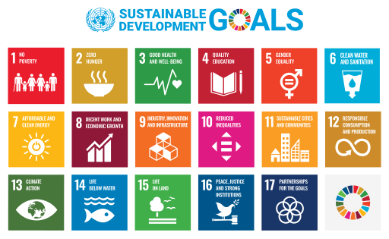
To integrate sustainability into museum practices, the ESG Integration strategy evaluates museums based on environmental, social, and governance factors. This approach promotes transparency, accountability, and responsible investment, fostering long-term financial returns while considering social and environmental impacts.

In summary, sustainability requires a holistic approach that addresses environmental, social, and economic concerns, with the goal of creating a prosperous and equitable future for all while safeguarding the planet's resources.

Environmental Sustainability and Climate Action
Climate change is one of humanity's greatest challenges affecting both people and the environment. However, climate change represents only part of a larger issue, highlighting an unsustainable relationship between human society and nature. Currently, the world is heading towards a temperature increase of three degrees or more compared to pre-1900 levels, which would be catastrophic.
Climate change impacts everyone, particularly affecting the most vulnerable populations who have contributed the least to the problem. It's crucial to understand that we all play a role in climate change to varying degrees, but we also have the capacity to contribute to climate action. People require access to opportunities and knowledge to effectively engage in climate action, and this right should be ensured for all.
Recognising the diverse nature of communities and social groups, it's essential to provide tailored information and opportunities for effective participation in climate action. Museums hold significant potential to facilitate climate action within communities.
Addressing climate change necessitates a fundamental shift in how museums operate and conceptualise their role in society. As existing institutions associated with modernity, museums are also part of the system contributing to climate challenges. Hence, they must adapt to effectively contribute to a sustainable future, alongside broader societal transformations.
The United Nations Framework Convention on Climate Change (UNFCCC) defines climate change as the alteration of climate directly or indirectly due to human activity. This distinction underscores the importance of recognizing human-induced climate change and its impact on the environment.

What drives Climate Change?
Climate change is primarily driven by human activities such as burning fossil fuels, land degradation, deforestation, methane emissions from various sources, fertiliser production, concrete manufacturing, and other industrial processes. Additionally, wasteful consumption patterns and high-energy lifestyles contribute to greenhouse gas emissions (for definition, see Glossary).

Types of Climate Action
Climate action typically involves two main approaches:
Mitigation: Actions aimed at reducing greenhouse gas emissions or enhancing nature's capacity to absorb them. This includes protecting forests, wetlands, and planting trees.
Adaptation: Measures to help communities and ecosystems cope with climate impacts. These actions encompass structural/physical adaptations (e.g., flood defences), social adaptations (education, awareness), and institutional adaptations (policy development).
In essence, climate action focuses on reducing emissions, preserving nature, and implementing adaptation strategies. It emphasises climate justice and a just transition, ensuring fairness and inclusivity in climate-related initiatives. It's important to clarify that when referring to ‘mitigation’, it specifically entails reducing emissions and enhancing greenhouse gas removal, not merely lessening the impacts of climate change.

Climate Neutrality, Carbon Neutrality, and Net Zero:
Understanding the distinctions among climate neutrality, carbon neutrality, and net zero can be challenging, but it's crucial to grasp their nuances. The UN Climate Neutral Now initiative offers clear definitions:
Climate Neutrality: A balance between GHG emissions and removals. Achievable at global/planetary level, and at stakeholder (companies, organisations, subnational authorities, individuals) level. At stakeholder level, only carbon credits from projects that capture GHGs in the long term can be used.
Carbon Neutrality: Action by a stakeholder (company, organisation, subnational authority, individual) to reduce and avoid emissions, and then compensate the remaining ones through the use of carbon credits. Use of carbon credits from projects that reduce, avoid and temporarily capture GHGs is possible. Not applicable at global/planetary level.
Net Zero: Considered synonymous with carbon neutrality, net zero entails achieving a balance between emitted GHGs and those removed from the atmosphere.
It's crucial to prioritise reducing greenhouse gas emissions before considering offsetting measures. Climate neutrality differs from carbon neutrality/net zero in that it doesn't allow short-term offsets; only projects supporting long-term GHG storage are acceptable. Many organisations are declaring their intention to be 'net zero,' but concrete plans backed by transparent reporting are essential.
For more definitions in relation to Climate Action and Sustainability, please refer to the Glossary.

UNFCCC, Kyoto Protocol, and Paris Agreement:
The United Nations Framework Convention on Climate Change (UNFCCC), established after the Rio Earth Summit in 1992, aimed to stabilise greenhouse gas concentrations to prevent anthropogenic interference with the climate system. Subsequent agreements, such as the Kyoto Protocol and the Paris Agreement, have committed signatories to reduce emissions and limit temperature rise. Countries develop their plans, known as Nationally Determined Contributions, to fulfil these commitments.

Social Sustainability
Social sustainability, part of the ESG framework alongside environmental and governance considerations, often takes a backseat in sustainability discussions dominated by environmental and economic concerns. Yet, all three dimensions are vital for sustainable development and require global attention.
Here are three definitions that collectively highlight the importance of equity, diversity, and well-being in fostering thriving, sustainable communities:
Social sustainability occurs when the formal and informal processes; systems; structures; and relationships actively support the capacity of current and future generations to create healthy and livable communities. Socially sustainable communities are equitable, diverse, connected and democratic and provide a good quality of life (Source: WACOSS, Western Australia Council of Social Services).
Social sustainability is a process for creating sustainable successful places that promote wellbeing, by understanding what people need from the places they live and work. Social sustainability combines design of the physical realm with design of the social world – infrastructure to support social and cultural life, social amenities, systems for citizen engagement, and space for people and places to evolve (Source: Social Life, a UK-based social enterprise).
The ability of a community to develop processes and structures which not only meet the needs of its current members but also support the ability of future generations to maintain a healthy community (Source: Business Dictionary).
This means that the aim of social sustainability is to meet people's socio-cultural and spiritual requirements fairly. It aims to enhance both societal and environmental conditions for human well-being. Metrics for social sustainability include factors like worker stress, job satisfaction, and attitudes toward sustainability efforts.
For organisations, this means that social sustainability centres on understanding organisational impacts on people and society. Although less quantifiable than environmental or financial aspects, it's crucial for the triple bottom line (TBL) model of accounting, which evaluates social, environmental, and financial performance.
It entails addressing issues like human rights, fair labour practices, health, safety, diversity, and community engagement.
Socially responsible organisations integrate social sustainability into their core strategies, recognising its importance in fostering positive relationships, mitigating risks, and enhancing their reputation.
Visitors increasingly demand socially sustainable institutions, rewarding transparent and ethical practices with loyalty. Partnerships with social sustainability organisations help museums become more ethical, transparent, and socially responsible, benefiting both society and business.
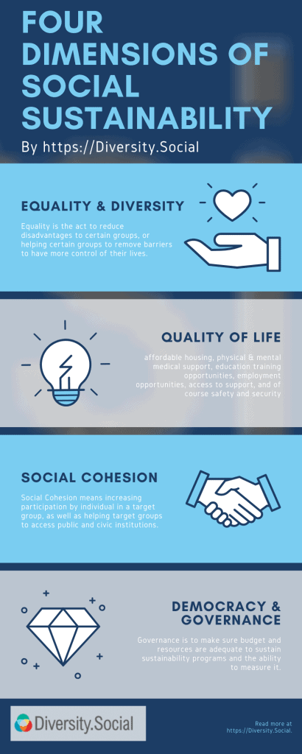

Sustainability, Human Rights and Social Justice
Climate change adversely affects numerous human rights, including the right to life, health, education, and participation in decision-making. Vulnerable groups, such as older people, small-scale farmers, and Indigenous communities, are disproportionately impacted.
The right to development, established in 1986, emphasises individual empowerment and participation in social and environmental improvement efforts.
The Aarhus Convention (1998) guarantees access to environmental information, public participation in decision-making, and the right to legal recourse.
The right to a healthy environment, increasingly recognised globally, is subject to legal challenges against governments for failing to act on environmental threats.

Museums and Social Justice
Museums play a crucial role in educating people about their environmental and developmental rights.
They should raise awareness about climate change's impact on human rights and advocate for a healthy environment as a fundamental human right.
Museums must address their own carbon footprint and return cultural heritage to communities, respecting their ownership rights.
A rights-based approach should guide museum practices, prioritising community engagement and empowerment.
Museums should recognise their intergenerational responsibility and empower people to engage in democratic processes to address climate-related human rights violations.

Economic Sustainability / Governance
Economic sustainability is about fostering growth while minimising environmental harm. It aims to create systems that consume natural resources slowly enough for future generations to use. Sustainable practices can reduce waste, limit emissions, and embrace renewable energy, all for the planet's long-term well-being. At the same time it involves practices that support long-term financial growth, meaning that it balances economic progress with positive environmental and social change.
Why is this important? Economic sustainability is vital because businesses relying on finite resources for production and growth face inevitable limitations. It ensures the longevity of the global economy by investing in alternative resources, addressing climate change and promoting sustainable energy and food production.
In addition to benefiting businesses, economic sustainability preserves natural resources, reduces emissions, and encourages greener practices. By reducing waste and embracing sustainability, businesses can lower costs, attract customers, and influence their communities positively.
Economic sustainability offers numerous advantages for the planet, people, and businesses. By reducing reliance on finite resources like oil and gas, it mitigates pollution and greenhouse gas emissions, benefiting the environment. From a business standpoint, economic sustainability helps companies improve their sustainability measures, reduce costs, and attract customers and investors. Moreover, it encourages individuals to adopt sustainable practices in their daily lives.
Economic sustainability is evident in various initiatives, such as recycling programs and sustainable development goals like those outlined by the United Nations.
Museums can transition to economic sustainability, through steps like adopting clean energy sources, involving staff, volunteers and visitors in sustainability efforts, and renovating buildings and exhibition spaces to reduce carbon footprints. By investing in sustainable practices and technologies, museums can ensure long-term viability while contributing to the fight against climate change. Ultimately, achieving environmental sustainability requires large-scale action and systemic change within the global economy.

Climate Justice
Addressing Climate Change and Sustainable Practices under consideration of the ESG (Environmental, Social, Governance) is the only way to Climate Justice. Climate justice, as defined by the IPCC, refers to a human-centred approach to addressing climate change while safeguarding the rights of vulnerable populations and ensuring equitable distribution of both the burdens and benefits of climate change impacts.
This is important, because climate change disproportionately affects different groups, often with the least responsible bearing the brunt of its impacts. Recognising and addressing this inequality is essential in climate action to avoid further disadvantaging already vulnerable communities.
Museums therefore, must cater to the needs of society as a whole, addressing human rights abuses and empowering communities to tackle climate change. This includes addressing their own greenhouse gas emissions and promoting education, awareness, and public participation in climate action.
For more information on climate justice, visit The Mary Robinson Foundation – Climate Justice, which emphasises human rights protection, equitable sharing of benefits and burdens, and inclusive decision-making. Additionally, resources on climate change laws and litigation can be found at the Grantham Institute, the Sabin Center for Climate Change Law, and the UNEP Global Climate Litigation Report.

Museums – A Central Role
Sustainable development, defined as meeting present needs without compromising future generations, integrates considerations of people, planet, and prosperity. Climate action must avoid creating new problems or shifting them elsewhere. Agenda 2030, adopted in 2015, serves as a blueprint for sustainable development, with 17 Sustainable Development Goals (SDGs) and 169 targets guiding global efforts.
Museums can align with the SDGs to plan climate action that creates social, economic, and environmental benefits (For further resources providing guidance on incorporating the SDGs into museum practices, please see here).
Museums all over the globe, attracting billions of visitors annually, have an extensive reach and great potential to promote climate action and sustainable development. Despite this potential, climate action remains a small part of museums' overall activities. Most museums have yet to fully integrate sustainable development into their operations, and many remain silent on the issue. Moreover, museums, often housed in old buildings, consume significant energy and may inadvertently support industries detrimental to the environment through their funding and investment choices.
In recent years, there has been increasing awareness and action within the museum sector regarding climate change. Museums have participated in conferences and submitted proposals to support international agreements like the Paris Agreement. Some museums are actively reducing their carbon footprint, but more concerted efforts are needed to meet the targets set forth in global agreements.
Museums must prioritise sustainability and actively contribute to climate action to ensure a positive future for all.

Managing the Museum’s Transition to Greater Sustainability
‘A just transition for all towards an environmentally sustainable economy […] needs to be well managed and contribute to the goals of decent work for all, social inclusion and the eradication of poverty’ (ILO, 2016).
The Paris Agreement emphasises the necessity of a fair transition for workers and the creation of quality jobs during climate action implementation. This ensures that climate efforts align with sustainable development principles, aiming to avoid unjust practices such as displacing communities or diverting food for biofuel production, which can exacerbate poverty and inequality.
Opponents of climate action often argue that it jeopardises employment, advocating to continue fossil fuel extraction. However, transitioning to a zero-carbon future is essential for long-term sustainability, requiring fair and inclusive strategies.
Various organisations, including the ILO, IISD, and B Corp, have developed guidelines and resources for a just transition. These frameworks prioritise workers' rights, dialogue with stakeholders, job protection, retraining, and education to facilitate the shift to a green economy.
Museums should integrate just transition principles into their operations and advocate for their inclusion in funding opportunities, skills development programs, and regulatory frameworks. By supporting human rights and sustainable practices across their supply chains, museums can contribute to equitable transitions and mitigate adverse social and environmental impacts.
Additionally, museums can leverage their role in public education and awareness to promote just transition principles. This includes fostering dialogue, providing access to information, and empowering communities to embrace green technologies and practices.
As investors, museums should align their financial activities with climate justice goals, divesting from unsustainable ventures and prioritising investments that support a sustainable future. Moreover, museums can engage with their stakeholders to ensure a strong social mandate for just transition, offering opportunities for consultation and collaboration.
Ultimately, museums have the potential to play a significant role in facilitating the transition to green jobs and sustainable practices, thereby contributing to broader societal efforts toward climate resilience and equity.

Museums and Climate Empowerment
Action for Climate Empowerment (ACE), outlined in Article 6 of the UNFCCC and Article 12 of the Paris Agreement, underscores the importance of public education, training, awareness, access to information, participation, and international cooperation on climate change matters. This framework serves as a crucial link between museums' work and global climate goals, emphasising their role in reducing greenhouse gas emissions and advancing climate education.
There are six essential elements to Climate Empowerment. By embracing these elements of ACE, museums can play a vital role in advancing climate empowerment and fostering a sustainable future for all.
- Education: Education aims to create lasting and meaningful shifts in understanding, especially among young individuals. This includes creating learning plans, training educators, and employing effective teaching methods. A successful program would result in a population deeply aware of climate challenges, fostering increased national involvement and dedication.
  - For museums, this means: Integrate climate change education into various programs, employing suitable teaching methods to cultivate not just knowledge but also attitudes and skills for addressing climate change. Education extends beyond schools and should continue throughout life.
- Training: Training programs aim to teach specific practical skills that can be immediately applied. Training emphasises learning through practical experience, benefiting individuals, communities, and organisations alike.
  - For museums this means: Museums should support their workers, as well as others, in addressing climate change through their work. By providing hands-on learning opportunities related to global challenges and local contexts, museums empower individuals to adapt to climate change and contribute to climate action. Museums can also ensure that their staff understand the goals of international agreements like the UNFCCC, Paris Agreement, ACE, and SDGs, incorporating these goals into both their public-facing activities and internal operations.
- Public Awareness: Public awareness efforts by governments, NGOs, intergovernmental organisations, and UN agencies have been significant, but there is still a large gap in outreach. Developing effective outreach programs that genuinely influence behaviour requires targeted and systematic communication.
  - For museums this means: Museums can contribute to public awareness of climate change, its effects on people and the environment, and actions to combat it through various communication channels. It is important for awareness campaigns not only to highlight problems but also to inform about available resources, support networks, partnerships, and positive initiatives addressing and adapting to climate change. Museums can utilise their exhibitions, collections, and partnerships to raise awareness of climate change, its impacts, and ongoing climate actions worldwide.
- Public Access to Information: Public access to information is vital for engaging citizens and organisations in addressing climate change. Making information freely available enables the development and implementation of effective policies and encourages active participation in carrying out these policies. Technologies like databases and the internet make it easier to provide climate-related information, data, and statistics to everyone.
  - For museums this means: Museums serve as repositories of knowledge, holding vast amounts of information in their collections. They can play a crucial role in disseminating this information widely. Additionally, museums can empower individuals to access the wealth of climate information available online, allowing them to curate their own knowledge to support climate action. Transparent access to information about government progress (or lack thereof) on climate change, at local, national, and global levels, can enhance climate awareness and action. People also require information on available initiatives, actions they can take, and guidance on how to implement these actions effectively.
- Public Participation: To ensure effective participation in addressing climate change, governments should involve civil society and mobilise the general public in decision-making and actions for climate mitigation and adaptation. This may require significant changes to traditional political processes, encouraging greater public engagement in policy making.
  - For museums this means: Public participation extends beyond simply receiving information from museums. Museums can facilitate interactions between various sectors, stakeholders, and the public, fostering the development of more effective policies and actions. Empowering individuals to contribute to their community's development and transformation is a fundamental human right.
- Cooperation: Cooperation is crucial for enhancing efforts related to Action for Climate Empowerment (ACE). Governments and stakeholders often require expertise, as well as financial and technical resources, to develop effective climate change programs. Sharing success stories, exchanging personnel, and building institutional capacity can benefit all countries.
  - For museums this means: Museums can contribute to cooperation by fostering collaboration between museums, various sectors, communities, and staff. By developing joint programs and leveraging synergies, museums can support and promote cooperation.

How to Start your Museum’s Sustainability Journey – in 8 Steps

Awareness
Acknowledge the considerable energy consumption by museums (e.g. cooling systems, lighting, old heating systems etc.), their potential reliance on funds from polluting sources, the possibility of wasteful practices in their operations (e.g. conservation & packing materials, temperature policies etc.), and the resistance to change inherent in some institutional structures.
Recognise the urgent need for action on climate change across all industries, including the museum sector, emphasising that the current rate of adaptation falls significantly short of what is necessary.
Remember that achieving sustainability involves more than just assessing environmental impact and managing energy usage. It also entails addressing issues such as gender equality, social inclusion, fair labour conditions, and access to education, as integral components of a fair and sustainable transition. This means that museums, as institutions of learning and heritage can be at the centre of this necessary change.

Assessment
Establish an overall baseline for your museum's sustainability journey by assessing its current practices, including the building, team capacity, priorities, and goals. This step lays the foundation for subsequent actions by understanding where the museum stands in terms of sustainability.
One way to start with this assessment is doing the questionnaire, provided in this toolkit.
If your museum already has a sustainability policy, or has sustainability goals incorporated into other policies, it will be part of this step, to examine existing policies and objectives concerning climate protection, greenhouse gas reduction, and other sustainable aims. Explore ways to integrate local, national, or global targets into your operations and value chain.

Sustainability Strategy Development
Engage with your community to determine priority actions based on local needs, while also raising public awareness about climate change. Align local needs with national or global targets. Recognise that the effects of your project and outreach efforts can extend beyond museum walls and positively impact the local community.
Conduct research on how to connect with policymakers in your area, particularly those involved in cultural policy, urban development, and sustainability. Be open to advice from stakeholders or potential funders who could influence your museum's impact.
Design a clear and concise Sustainability Mission Statement and Sustainability Policy, which summarise your aims and objectives and align them with the results of your research.
You can use the instructions for the DIY Sustainability Mission Statement and Sustainability Policy, provided in this toolkit.

Cultivation
Seek inspiration from innovative initiatives within and outside the cultural sector, while evaluating the progress at your own museum, to develop projects that engage stakeholders and funders.
Forge partnerships with museums, cultural entities, institutions, businesses, and community stakeholders committed to sustainability and climate action. Participate in established networks focused on these goals, collaborating with fellow museum professionals.

Advancing Sustainability
Continuously evaluate your museum's current achievements in alignment with your Sustainability Mission Statement and Sustainability Policy and climate adaptation objectives.
Incorporate the sustainable transition of your museum into an action plan with short term (to be achieved within the next year), medium term (to be achieved within 2-3 years) and long-term goals (to be achieved in 5 years or more), and designate a 'green team/person' to oversee implementation. Ensure that all stakeholders, board members, employees, volunteers, funders, financiers, partners, supporters and the community, are well-informed about these initiatives.
One way to do this is by making your Sustainability Mission Statement and Action Plan (including all actions already taken) accessible to the public on your website and welcome desk.
Identify additional actions your museum can take to contribute to sustainability while upholding its standards and responsibilities. For instance, consider organising workshops or public forums to explore the intersection of heritage and sustainability and enhance existing educational and social inclusion programs that your museum may already offer.

Sustainable Projects for Community transition
Implement a project, regardless of scale, that aligns with your institution's values and contributes to the sustainable evolution of your community.
Utilise established assessment frameworks to evaluate your initiatives and substantiate your proposals. Identify focal areas for improvement and develop compelling arguments to support your project and campaign. For instance, when conducting an energy audit, identify optimal strategies for improving energy efficiency or transitioning to renewable energy sources, along with estimating associated costs.

Results and Commitment
Communicate your findings and proposals to decision-makers and potential funders, emphasising your institution's significance to the community and its steadfast dedication to sustainable development. Showcase existing successful initiatives while providing insights into areas for improvement, supported by a blend of data and compelling narratives about the museum's impact.

Advocate Change and Inspire
Advocate for systemic changes by integrating your research findings into existing policies or future funding programs. Engage with social media and the local media outlets with organised briefings and timely press releases, ensuring the public is informed about your initiative's objectives and progress.
Collaborate with stakeholders and funders to effectively communicate the necessity of your museum's sustainable transition and its broader implications for the community.
Leverage local partnerships to advocate for essential changes. Recognise that achieving a successful sustainable transition demands active participation from stakeholders and the wider community
Always share your progress with your network to continue the cycle of inspiration and collective action in the sector!

Awareness: Start Thinking about Sustainability in your Museum – 15 Questions
- How does climate change affect your area (severe weather, flooding, heat etc.)?
- How will these changes impact your museum?
- Who else within the community will be impacted and in what ways?
- How do you add to climate change locally and globally?
- What does your community believe your museum does?
- What resources do you have for climate action, or could you create them?
- Which roles would benefit your community and environment the most in tackling climate change?
- Can your museum contribute to creating these roles in any way?
- What changes are needed from you, your colleagues, and your museum to fulfil those roles?
- What are the gains and losses in making these changes? Who benefits, especially those currently marginalised?
- Who decides how you adapt to certain changes: you or your community?
- Whose opinions matter in making these decisions?
- What is your vision and commitment to climate action?
- Do you know when you will achieve carbon neutrality?
- How rapidly are you reducing your carbon footprint without taking offsetting into consideration?

1. Start Re-thinking Misconceptions
Typical Misconceptions | Alternative Framing
Climate change only poses a challenge for the future | Climate change affects all: past, present and future
Climate change is a scientific problem | Climate change stems from cultural influences
Addressing Climate Change is highly complex | Addressing climate change can be very straightforward
Climate change is for politicians to address | Climate change is for everybody to address
We have to minimise the harm that we do | We have to maximise our positive impact
It’s more important to uphold professional standards than address climate change | It’s more important to change professional standards and practices to meet the requirements of climate action
Other people and countries should address climate change | Before expecting others to act, I should take the initiative on climate change
Climate action is about solutions | Climate action is about responding proactively
Climate action means changing people’s behaviour | Climate action entails empowering participation

Assessment – Setting a Baseline
The below suggested questionnaire is a great way to establish a baseline for your museum, without too much time-consuming preparation.
In addition to this, it is recommended to explore current schemes for free assessments and beneficial memberships that can help you along this journey.
We particularly encourage museums to sign up to be part of Museums and Galleries Scotland’s Scottish Museums Climate Network offering a space where museum staff and volunteers can discuss all things climate and biodiversity. Designed to encourage conversation, it is a space to share ideas, challenges, events and support.
The network is on Microsoft Teams with channels dedicated to specific themes. To join you can email Climate@museumsgalleriesscotland.org.uk.
We further recommend applying to: Business Energy Scotland’s free Energy Efficiency Assessment.
Please also check the Resources of this toolkit to find further helpful links.

Questionnaire to Establish a Baseline

Your name:

Name of your museum:

What is your role at the museum?

What are your other responsibilities at your museum?
Volunteer
Staff member
Board member / Trustee
Curatorial / Collections Care
Education
Marketing / publicity
Fundraising / development
Events
Exhibitions
Building maintenance
Cafe
Shop / Retail
Health & Safety
Strategic / Policies / Accreditation
Administration
Front of House / Operations
Other:

Please select what best describes your museum (check all that apply)
Small
Medium
Entirely volunteer run
Up to two members of full-time staff
Up to five members of full-time staff
More than five members of full time staff
One or more member of the team are tasked with improving sustainability
Other:

Where are your visitors from?
Local
National
International within Europe
Overseas

In 1-2 sentences please describe your institution or work.
For example, are you a conservation lab specialising in ethnographic collections or a science museum working with exhibitions and outreach programs but not collections?

Please briefly describe your building (if applicable)
For example, do you work in a small historic building or a large modern complex or is all of your work remote?

Do you have specific goals or targets in place for your museum?

Which sustainability topics are you/your organisation most interested in to start your journey? Please rate the following topics according to priority level. 1 = not a priority right now, 5 = highest priority.
Sustainability strategic planning
Building a sustainability project
Sustainability policies
Climate change education and communication
Environmental sustainability
Energy consumption reduction/efficiency
Waste management and reduction
Materials/alternatives for exhibitions, conservation labs, etc.
Water management
Accessibility
Diversity and inclusion
Equity
Social justice and human rights
Social sustainability
Decolonization
Sustainability strategic planning
Building a sustainability project
Sustainability policies
Climate change education and communication
Environmental sustainability
Energy consumption reduction/efficiency
Waste management and reduction
Materials/alternatives for exhibitions, conservation labs, etc.
Water management
Accessibility
Diversity and inclusion
Equity
Social justice and human rights
Social sustainability
Decolonization

What are your museum's motivations for becoming more sustainable? Why are you taking part in this project?

In your own words, where are you (or your museum) currently at in your journey? What have you already done and what successes can you build on?

Do you already have a team member tasked with sustainability?
Yes
No
No - but we want to nominate one!

If so, what is their role?

Is sustainability included in your museum's role descriptions?
ie. supporting cycling to work or reusing exhibition components or working from home
Do you have support to learn more about sustainability (attend meetings/trainings, action execution, data collection, research, communications, etc.) as part of your role?
Yes
No
Other:

Do you currently track your energy, water and waste? This can be recorded by taking readings or looking at the bills from your suppliers.

Have you done any carbon calculations or energy audits before? Have you done any waste audits before? If so, please briefly describe methods and results.

Does your museum participate in any carbon offset programs or offset any of their emissions? If so, which ones?

Has your museum identified areas of improvement that you wish to engage with in your sustainability journey? What are your priority areas? If so, please briefly describe.

Do you already have an organisational action plan/strategic plan? (Often part of an Accreditation return).
Yes
No
No - but we want to make one!

Do you have sustainability policies? Which sustainability policies do you have in place? (This can include specific policies for sustainable practice, or can include sustainability language into existing policies) Please select all that apply:
Sustainability Policy / Environmental Policy / Net-Zero Policy
Mission & Vision Statement
Collections Care
Transportation and Mobility
DEAI - Ethics
Loan Agreements
Third Party/Procurement
Climate Change Statement
Waste Policy
Meetings & Events Policy
Other:

Is your museum in partnership with other organisations, government bodies, or social actors with common sustainability goals? If so, please provide a short description of the partnership(s) and its/their aims.

Does your museum have an allocated budget for sustainability?
Yes
No
Not sure
Other:

What are the biggest opportunities your museum sees looking forward?

What might be some potential roadblocks or challenges?

What are your personal motivations for becoming more sustainable?

Waste Hierarchy
Framework and regulation focused on waste prevention, reduction, reuse, recycling, recovery, and disposal – in that order.
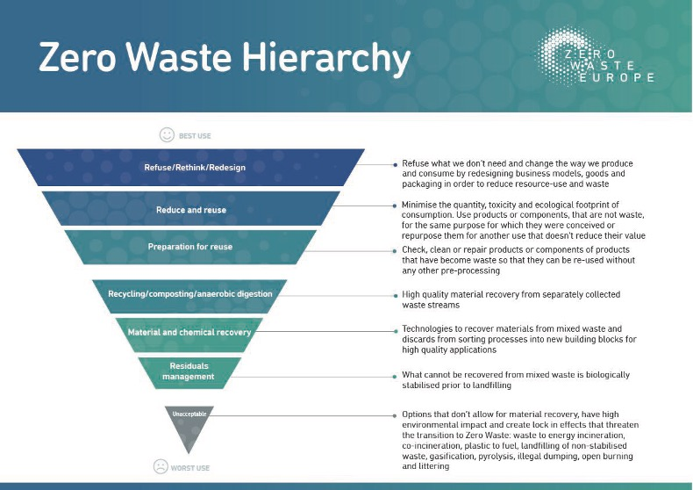
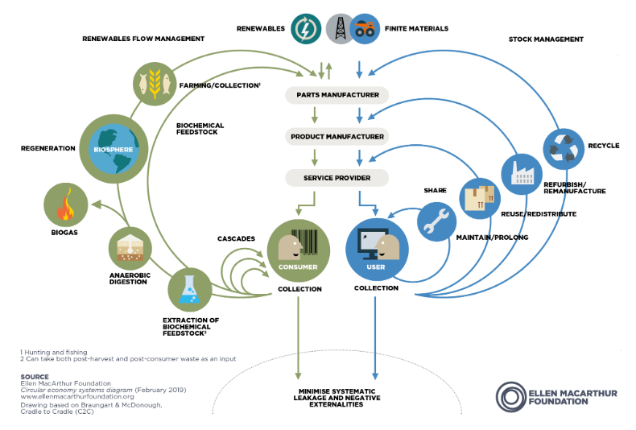

Greenhouse Gas Emissions
Climate mitigation involves human interventions to reduce greenhouse gas emissions or enhance nature's capacity to absorb them. It's crucial for addressing climate change, which is mainly caused by altering the atmosphere's composition. Mitigation includes reducing emissions and implementing carbon removal methods.
Carbon removal methods involve natural or technological approaches like agroforestry, bioenergy with carbon capture and storage (BECCS), and soil carbon sequestration. Thematic areas for mitigation include energy, transportation, buildings, industry, waste management, and land management.
Key actions to reduce emissions include transitioning away from fossil fuels, promoting plant-based diets, and reducing reliance on electrical goods. The UNFCCC's Climate Neutral Now initiative outlines a four-step approach to greenhouse gas reduction: measure, reduce, contribute, and report.
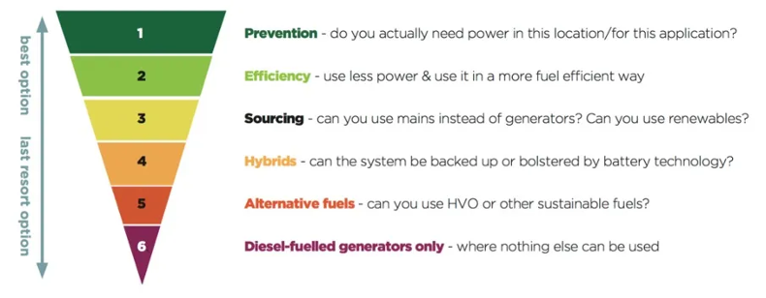
Greenhouse gas emissions are categorised into three scopes, with Scope 3 emissions being the most challenging to control but often comprising the largest portion of total emissions for businesses and organisations.
Direct emissions (known as Scope 1): from onsite combustion of fossil fuels in heating and cooling, and fossil fuels used by fleet vehicles.
Indirect emissions (Scope 2): from purchased electricity and steam, in terms of the emissions produced in the production of that energy.
Optional emissions (Scope 3): Examples include employee business travel and commuting, consumption of goods and services, which includes visitor travel to museums, investments and waste management.

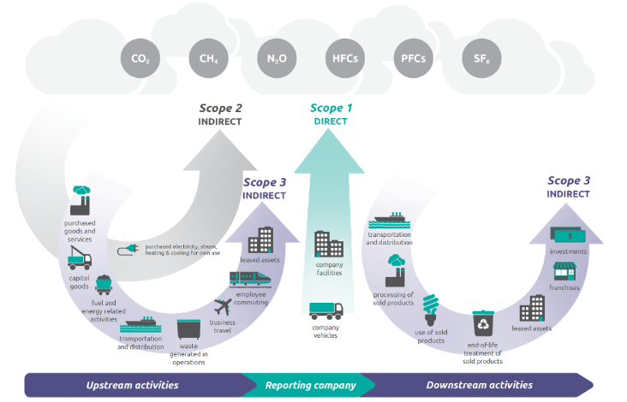

According to Museumsforclimateaction.org, where the table below is from, Scope 1 and 2 emissions are relatively easy to deal with, at least in theory, by rapidly shifting away from fossil fuels in heating, energy and transport, and changing working practices and standards that use these, or that are inefficient. The actions to take are really very clear.
There are 15 categories of Scope 3 emissions, which museums can act on as follows:
Category | Description | Possible Activities for Museums to Implement
Purchased goods and services | emissions from the production of products purchased or acquired | purchase less goods and services: consume less, purchase low or, ideally, zero carbon goods and services
Capital goods | emissions from the production of capital goods | purchase second-hand capital goods (e.g . vehicles, equipment), purchase less capital goods through greater sharing of resources
Fuel and energy-related activities | emissions related to the production of fuels and energy purchased and consumed | switch to renewable energy sources, maximise energy efficiency, consume less energy, change environmental requirements to be more in keeping with Paris Agreement targets, and where environmental controls are absolutely necessary in collections stores and exhibitions, implement them through targeted localisation
Upstream transportation and distribution | transportation and distribution of products purchased | purchase less products, reduce transportation emissions by insisting on low or, ideally, zero carbon emissions transport, maximise efficiency of transportation
Waste generated in operations | emissions from third-party disposal and treatment of waste generated | consume less to produce less waste, enhance sharing and reuse of resources to minimise waste production
Business travel | emissions from the transportation of employees for business-related activities | reduce business travel emission, notably through reducing business travel (not just Business Class, all business travel) and replacing with online meetings
Employee commuting | emissions from the transportation of employees between their homes and their worksites | provide employees with support (season ticket loans) to use public transport, encourage and empower employees to work from home
Upstream leased assets | emissions from the operation of assets that are leased (e.g. storage in buildings owned by others) | reduce the need for leased assets, by prioritising disposal and or/dispersion of low quality or unused assets, and greater sharing of assets among partners to reduce the need for storage
Downstream transportation and distribution | emissions from transportation and distribution of sold products in vehicles and facilities owned by others. | reduce travel resulting from museum activities, including loans, touring exhibitions, and where travel cannot be reduced, reduce the emissions by choosing low-emissions transportation methods, and through collaboration to ensure the effectiveness of travel itineraries
Processing of sold products | emissions from processing of sold intermediate products by third parties subsequent to sale | reduce emissions by reducing the number and impact of touring exhibitions, reduce emissions involved in production of e.g. publications and other merchandise
Use of sold products* | emissions from the use of goods and services sold [includes free goods and services] | reduce emissions associated with visitor travel to museums, reduce emissions associated with visitor experience in museums
End-of-life treatment of sold products | emissions from the waste disposal and treatment of products sold [or otherwise produced] | reduce emissions from waste from e.g. temporary exhibitions through reducing their production, minimising construction, increasing sharing of resources with other museums and other organisations, and by prioritising easily disposable and biodegradable materials
Downstream leased assets | emissions from the operation of assets that are owned by the reporting organisation | reduce the number of assets leased (where there are any)
Franchises | emissions from the operation of franchises (e.g. book production or distribution, marketing distribution) | ensure that any franchised operations prioritise sustainable practices in line with Paris Agreement targets
Investments | emissions associated with the reporting company’s investments (e.g. activity related to endowments, pension funds, bank accounts) | ensure investments of all kinds are directed towards sustainable development, eliminating support and benefit from activities that are socially and environmentally damaging; partnerships and relationships may be considered as a form of investment

For useful tools to calculate your museum’s emissions, please refer to our Resources.

Sustainability Strategy Development
The development of a Sustainability Mission Statement and a Sustainability Policy demonstrate your museum’s commitment to sustainability. It helps focus on making the museum more environmentally friendly, highlights areas where improvements can be made, is integral to funding applications and can be an important point of reference.
Sustainability entails meeting current human needs without compromising the ability of future generations to meet their own needs. It involves preserving ecosystems and natural resources while ensuring a balance between human resource consumption and Nature's replenishment capacity.

Sustainability Statement or Sustainability Policy?
Every museum has a different approach and different statements and policies in place. Some museums opt for a Sustainability Statement, some museums write a Sustainability Policy and others write sustainable approaches into already existing policies. We recommend that you do all of it, to incorporate sustainability as much as possible into your daily proceedings and to get the best results.
It can be confusing, which is why we have prepared some very short definitions for Sustainability Statements and Sustainability Policies, along with recommendations on how to use them.
Sustainability Statement: A statement recognises the need for action, sets out your museum’s values, commitments and vision and briefly explains that actions will be taken to achieve your goals. It usually comprises 2-5 sentences. This is ideal to be placed on your website and welcome desks, to raise public awareness and openly state your commitment to sustainability.
Sustainability Policy: A policy accomplishes a similar goal to the Sustainability Statement, but is more specific and it is possible to reference or add further policies, like for example: travel, waste, procurement etc. Sustainability policies typically are not much longer than one page. This is ideal to help support action and guidance for internal operations, as well as to use them as a point of reference for projects, funding applications and further developing strategies. Once your Sustainability Policy is done, it is a good idea to include sustainability practices into other policies as well.
Sustainability Action Plan: An action plan builds on the framework set out in your statement and policy and details your museum’s specific short-, medium- and long-term goals to keep track of activities and continuously evaluate your progress. This is a great way to cultivate and advance your sustainability journey.

Sustainability Mission Statement – How to?
A Sustainability Mission Statement should always contain the following components: Recognition, values, commitments & vision, activities and goals.
Here are some examples for Sustainability Mission Statements, which you can use to adjust to your personal needs:
- Acknowledging the importance of sustainability for museums, we are committed to integrating sustainability into all aspects of our operations, guided by our vision, mission, and values.
Sustainability encompasses various facets, including environmental stewardship, community engagement, financial stability, and skill development. Our goal is to foster individual and community growth within a sustainable framework for success.
Our sustainability framework comprises:
Being a trusted partner sought after by organisations and individuals.
Creating a special place that attracts visitors and garners support.
Providing a preferred workplace conducive to personal and professional growth.
Being a responsible steward of our environment.

- At our museum, we recognise the vital importance of sustainability, especially in the context of museums, where preserving cultural and natural heritage is paramount. By embracing sustainability, we ensure the longevity of our resources and contribute to a healthier environment for future generations.
Our core values include respect for cultural diversity, environmental stewardship, and community engagement. We are committed to integrating sustainability into every facet of our operations, from exhibition design to daily practices. This commitment is embedded in our vision of fostering understanding and appreciation for cultural heritage while minimising our ecological footprint.
Actions we will take include implementing energy-efficient technologies, reducing waste, and promoting sustainable transportation options for staff and visitors. These will help in achieving our goals of carbon neutrality and enhancing accessibility to underserved communities.

- As advocates for environmental conservation, we understand the critical role museums play in promoting sustainability and fostering dialogue about pressing environmental issues. By adopting sustainable practices, we aim to minimise our ecological impact and inspire others to do the same.
Our museum values inclusivity, innovation, and stewardship of cultural and natural resources. We are committed to integrating sustainability into our institutional culture and operations, guided by a future-oriented vision of resilience and responsible resource management.
Actions we will take include implementing green building practices, reducing water and energy consumption, and promoting eco-friendly transportation options. Our goals include achieving LEED certification, hosting educational programs on environmental sustainability, and serving as a catalyst for positive change within our community.

- As custodians of cultural heritage, we understand the importance of sustainability in preserving our planet for future generations. By adopting sustainable practices, we uphold our responsibility to protect both cultural objects and the environment.
Our museum values stewardship, innovation, and community engagement. We are committed to integrating sustainability into our institutional ethos and operations, guided by a vision of environmental stewardship and social responsibility.
Actions we will take include implementing energy-efficient technologies, reducing water consumption, and promoting sustainable transportation options. Our goals include achieving carbon neutrality, minimising waste generation, and fostering environmental literacy among our visitors and stakeholders.

Sustainability Policy – How to?
Once your Sustainability Mission Statement is written, you are ready to start drafting your Sustainability Policy, as the statement will be the ideal basis for this next step.
Further to having your Sustainability Mission Statement, you will need to do the following:
- Define the purpose and scope of your policy: Is it a general Sustainability policy? Will you later want to add more specific policies? Is it connected to other, already existing policies?
- Contextualise with reference points to aid credibility: e.g. This policy is in alignment with the Paris agreement / UN SDGs / local agreements etc.
- Develop Policy Principles and values, based on the ones in your overall Mission Statement / Strategic Plan and your Sustainability Mission Statement. This step is helpful to further define your museum’s sustainability goals.
- Establish Policy Implementation and evaluation mechanisms, like key performance indicators and set targets, to be able to evaluate your progress throughout.
- Draft your policy.
- Include a person of contact in the policy, who is responsible for the implementation and reviews.
- Get approval of the policy: The policy needs to be signed, dated and endorsed.
- Communication & Implementation: Share the new policy with everyone in the team and make it accessible to any visitors who are interested to assure its greatest possible success. Also provide further resources for your staff and volunteers to make sure that everyone understands their role in the new policy’s implementation (For this you can refer to our resources document).
- Make sure the policy is reviewed and updated annually, in order to stay relevant.

With kind permission from Ki Futures, in the following you can find a draft-policy, which you can adjust to your needs:
Introduction
[Organisation name] is committed to promoting sustainable practices and upholding the principles outlined in the United Nations Sustainable Development Goals. We recognize our impact on society and the environment, locally and globally, and are committed to taking action to address our activities and ensuring best practices and communicating this within our community. This policy outlines our framework for action on sustainability within the organisation.
Principles
1. Compliance with Relevant Legislation and Codes of Practice [Organisation name] will manage and control its environmental risks in a sustainable manner by complying with all relevant and applicable legislation and codes of practice. We will seek to operate within the government's commitment to energy, sustainability, and good environmental practice. The [relevant framework or legislation] sets out key objectives and criteria on which sustainable development activities should focus.
2. Incorporating Sustainable Development Issues into Policy Decision-Making [Organisation name] will endeavour to incorporate sustainable development issues into future policy decision-making at all levels.
3. Conservation of Energy, Water, and Natural Resources [Organisation name] will support and encourage the conservation of energy, water, and natural resources and the reduction of waste through reuse and recycling wherever possible.
4. Minimising Harmful Effects [Organisation name] will ensure that the risk of any potentially harmful effects through any of its actions is minimised wherever practicable, thereby aiming to reduce the impact on the environment.
5. Procurement of Goods and Services with the Least Environmental Impact The procurement of goods and services with the least environmental impact in production, delivery, installation, use, and disposal will be considered by [organisation name] wherever practical and appropriate. Contractors and suppliers will be encouraged to develop environmentally preferable goods and services and to be aware of sustainability issues.
6. Education and Communication [Organisation name] will undertake to communicate its sustainable development policy to staff and stakeholders, educate and motivate its employees and contractors to understand the principles of sustainable development, operate in an environmentally and socially responsible manner, and conserve resources wherever practicable.
7. Identifying Sustainable Development Priorities [Organisation name] undertakes to identify sustainable development priorities and to develop plans to address them.
Approved by:
List the relevant approving bodies, such as the Trustees, Board, Executive Director, and Staff
Conclusion
By implementing this sustainability policy, [organisation name] aims to promote environmental stewardship and social responsibility throughout its operations and to contribute to the achievement of the United Nations Sustainable Development Goals. We will continually review and improve our sustainable development practices to ensure that we are meeting our commitments and making a positive impact on our communities and the planet.

Cultivation
As inspiration to draw from for possible sustainability initiatives, we have compiled a table of measures, which museums can take to further their sustainability journey. This table of Sustainability measures will include measures your organisation has already taken, or some that are not applicable for your circumstances and it is by no means an exhaustive list, but just a start to your own research journey towards finding innovative projects and relevant funders.
Some funders you may want to consider are:
- Board na Gaidhlig
- Cairngorms National Park
- Creative Scotland
- Energy Savings Trust
- Highlands and Islands Climate Hub
- Highland Council
- Highland Third Sector Interface
- Historic Environment Scotland
- Museum Galleries Scotland
- Museum Association
- National Lottery Community Fund
- National Lottery Fund for Projects
- National Lottery Fund for Heritage
- National Archives
- National Museums Scotland
- Radcliffe Trust
- Royal Society
- Schroeder Charity Trust

Sustainability Project Ideas
In the following two tables, you can find some ideas for different projects for environmental and social sustainability. As explained above, many of these projects have a direct impact on your museum’s financial sustainability and therefore also are projects to improve economic sustainability / governance.
For all of them, Sustainability Strategic Planning will be the first step, as this means you will be able to respond to changing political, social, environmental and economic contexts and have a clear long-term purpose that reflects society’s expectations of museums, as well as plan long-term, take full account of sustainable development in all your museum’s activities and policies and work within available resources.
Please note that this table only contains suggestive ideas for projects, to help you come up with your own projects. It is by no means exhaustive and the applicability of the different suggestions will highly depend on your individual museum.
For some further ideas on sustainability projects, please also have a look at some very inspiring museum projects all around the world, which you can find in our resource section, here.

Environmental Sustainability Projects

General Goals | Short Term | Mid & Long Term
- Join with other museums, and other organisations, in partnerships and mergers, where it is the best way of meeting their purpose in the long term.  - Strive for excellence, building deep long-term relationships with a range of audiences.  - Consider the potential for demonstrating and encouraging sustainable development.  - Value and protect natural and cultural environments and be sensitive to the impact of the museum and its visitors on them.  - Make the best use of energy and other natural resources and minimise waste, setting targets and monitoring progress towards them.  - Manage collections well, so that they will be a valued asset for future generations, not a burden. | - Ask suppliers for information about their carbon emissions  - Climate Change education: Remind staff & volunteers about the importance of sustainability, as their understanding of energy consumption is an essential first step in improved facilities management.  - Create a zero-waste event & inform, inspire and empower visitors to respond to the problems of waste and how it contributes to climate change  - Change to sustainable cleaning products and office supplies  - Examine staff commuting patterns and encourage sustainable alternatives where possible  - Find your energy drainers (through surveys and energy bills)  - Seek out and plug up leaks and draughts  - monitor water consumption more closely  - identify opportunities to reduce water consumption  - Recycle and compost your waste  - Reduce waste as much as possible  - Review collection-care standards and the way that they are interpreted and applied by lenders, funders and support organisations  - Flexible loan agreements  - curate remotely if/when possible  - For museum shops: Remove plastic bags from the gift shop; Less plastic wrapping on products; Order from environmentally friendly wholesalers; Get more locally crafted products; Stop using bubble wrap and use a recycled paper alternative onsite and in online deliveries; Use single-use bags made from 100% recycled paper; Sort delivery packaging to separate paper, cardboard, PET and HDPE plastics for recycling  - For museum cafes: No single use plastics; Support local production; Reduce any single use item; Introduce water stations to encourage our visitors to refill bottles; Bottled water sold only in glass bottles; Buy eggs free-range and as local as possible; Don’t use palm oil and avoid stocking items that contain it, Offer and promote vegetarian and vegan options | - Introduce sustainable procurement guidance & build sustainability decisions into procurement processes  - Create a sustainability hub & raise awareness of recycling best practice  - re-using and retrofitting (e.g. green roofs, improved HVAC systems, improved facade etc.)  - Switch to LED lighting solutions  - Motion sensors for all lighting  - Solar panels  - Air source heat pumps  - Use renewable energy  - insulate roofs and floors  - recycle greywater from sinks and rainwater where possible  - fitt dual-flush cisterns that reduce the volume of water used to flush toilets  - install sensor-controlled or push-button taps  - monitor waste more closely and undertake a series of waste audits (General waste can be incinerated to generate useful heat; Mixed recycling can be sent to a UK processing facility, sorted into its component parts and then sent on to a reprocessing plant; Food waste can be sent for anaerobic digestion and made into fertiliser. The gas emitted from this process is captured and used for energy; Cardboard can be taken to a card pulping plant and turned into new products; Glass can be taken to a glass factory for reuse  - work in close partnerships with other museums, or other types of organisations, to share resources  - work with suppliers to make use of take-back schemes for specialist equipment and packaging  - For museum shops: Use clothing made of 100% recycled, BCI or organic fabrics; Work to replace virgin polyester used in accessories with more sustainable alternatives; Offer soft toys filled with recycled PET, Make product packaging as easy as possible for customers to recycle by choosing widely recyclable materials where possible and providing clear disposal information on new products  - For museum cafes: Start a community garden to grow some of the food for the café; Use the sale of every water bottle to help fund clean water projects across the globe.

Social Sustainability Projects

General | Short Term | Mid & Long Term
- Develop staff, offer satisfying and rewarding employment and learn from their experience and that of others.  - Always consider the importance of physical and psychological comfort for all in cultural venues  - Contribute responsibly to the social, cultural and economic vitality of the local area and wider world.  - Creatively reimagine the way museums work, who they work with and what they value. It covers all areas of practice and creates a framework to better support people and institutions. Decolonising is a collective activity, which can be messy, thoughtful, imaginative, and emotional  - Remove the barriers that our colonial heritage presents  - Recognise the trauma and suffering caused by our colonial heritage  - Represent, celebrate and co-produce with people of colour and other diaspora communities | - Improve accessibility through e.g. ramps, low sensory stimulation times, sufficient chairs for rest throughout the exhibition  - Increase your knowledge about collections, learn more about the objects that represent marginalised cultures & diaspora  - Knowledge exchange with other organisations who have close relationships with the relevant communities  - Draft a full policy on decolonisation and Repatriation Though the World Cultures  - Encourage a shift in thinking about the context and display of collections  - acknowledge that museum interpretation requires updating | - Introduce a bike station  - Improve accessibility and inclusivity through e.g. wider doors for greater accessibility; online accessibility; apps; audio guides, online map, electric door openers, guided tours for blind visitors, tactile guide paths; secured stairs with handrails and visual contrasting non-slip stair nosings, audio information; quiet zones; resting zones; assistive listening devices; audio induction loops; visual information; online exhibition; virtual tour; lowered counters at information desk, restaurant and shop  - Have the policies peer reviewed  - Review interpretation for updating & update interpretation  - Review museum objects and identify objects for repatriation

Advancing Sustainability
Once your Sustainability Mission Statement and Sustainability Policy are in place, it is important that you will continuously evaluate your museum's current achievements in alignment with these and climate adaptation objectives.

Adaptation
Adaptation involves adjusting ecological, social, or economic systems in response to climate change impacts. It encompasses changes in processes, practices, and structures to mitigate damages or capitalise on opportunities arising from climate change. Museums and their communities must develop and implement adaptation solutions to address current and future climate impacts effectively.
Successful adaptation requires the active engagement of stakeholders, including governments, organisations, public and private sectors, civil society, and effective knowledge management. The IPCC identifies three main clusters of adaptation options: structural/physical, social, and institutional. Structural/physical options include engineered infrastructure, technological innovations, ecosystem-based approaches, and essential services. Social options encompass educational, informational, and behavioural strategies. Institutional options involve economic measures, laws and regulations, and government policies and programs.
Principles of successful climate adaptation, such as sustainability, proportionality, collaboration, effectiveness, efficiency, and equity, guide adaptation efforts. These principles ensure that adaptation actions consider long-term impacts, are integrated into existing processes, involve collaboration, are context-specific and flexible, and promote fairness.
Museums play a crucial role in supporting climate adaptation and resilience. They can contribute by safeguarding cultural and natural heritage, integrating climate adaptation into educational programs, promoting cultural participation for all, supporting sustainable tourism, conducting research, and aligning internal and external operations with climate adaptation goals. By adhering to the principles of adaptation and actively participating in the adaptation cycle, museums can effectively contribute to building resilient communities and promoting sustainable development.

Action Plan
Now it is time to incorporate the sustainable transition of your museum into an action plan with short term (to be achieved within the next year), medium term (to be achieved within 2-3 years) and long-term goals (to be achieved in 5 years or more).
In the following you can find some examples for different areas relevant to sustainability that show you how to define them, the potential aims and current position, which can then be used to develop an action plan from this process (you will need to adjust this process specifically to your organisation).
At the end of this section, you will further find an exemplary environmental action plan, which you can adjust to your organisation's specific needs.

Sustainable Cultural and Natural Heritage
Summary: Cultural and natural heritage face threats from climate change, necessitating management strategies that both address and adapt to climate impacts without further exacerbating the problem. The goal is to safeguard heritage effectively while ensuring its contribution to climate action and accessibility to all.
Aims: Determine preservation methods aligning with the Paris Agreement and Sustainable Development Goals. Identify heritage assets that can aid emission reduction or climate adaptation and ensure equitable access to them. Integrate societal, cultural, and environmental impacts into decision-making processes and energy planning. Consider future climate scenarios and adaptation plans. Plan for potential museum relocation due to climate change, prioritising community needs and sustainability. Determine acceptable risk levels for museum closure. Collaborate with stakeholders to shift towards a more proactive role in heritage preservation amidst climate challenges.
Current Position: Assess the extent of climate threats to heritage in your area and evaluate how current heritage management practices affect broader cultural and natural assets. Identify marginalised groups unable to access their heritage due to museum practices.

Integrating Climate Action into Museum operations
Summary: Addressing climate change requires collective action from all sectors, including museums. It's imperative for museums to embed climate action into daily operations and decision-making processes. This involves reducing carbon footprints, aligning investments with climate goals, and adopting policies in line with the Paris Agreement and Sustainable Development Goals.
Aims: Hold museums accountable for historical climate damage and establish ambitious emission reduction targets. Educate staff on national emission responsibilities and emission reduction ambitions. Prioritise plans to reduce Scope 1 and 2 emissions from fossil fuels, energy, and transportation. Develop strategies to address Scope 3 emissions from visitor travel and waste management. Commit to concrete actions, measurement, offsetting, and regular reporting of climate actions to stakeholders. Ensure reporting includes both positive actions and negative impacts. Make climate action a part of everyday responsibilities through recruitment, work plans, staff reviews, and resource allocation. Prepare for climate impacts on the organisation and community, ensuring readiness to cope with those impacts.
Current Position: Assess the greenhouse gas emissions of the museum and individual work roles. Consider indirect emissions and trends in emission reduction or increase. Determine the timeline for achieving carbon neutrality or Net Zero emissions.

Educating for Climate Engagement
Summary: Education is essential for fostering climate action, providing individuals of all ages with the knowledge, attitudes, and skills needed to address climate change effectively. The goal is universal climate literacy and empowerment for meaningful participation in climate solutions.
Aims: Integrate climate mitigation and action into educational and awareness programs. Identify necessary resources to support effective climate mitigation and adaptation efforts. Provide targeted information to communities regarding specific climate impacts for enhanced preparedness. Develop strategies to assist high emitters in reducing their carbon footprint. Ensure equitable access to climate education for all, focusing on building necessary knowledge, attitudes, and skills for active participation in climate action.
Current Position: Assess the distribution of climate knowledge, attitudes, and skills within your community. Identify groups lacking meaningful engagement in climate action and evaluate participation in current affairs. Understand local climate impacts and how existing educational programs address them, including utilisation of cultural heritage for learning opportunities.

Collaborative Climate Action in Museums
Summary: Partnerships between museums, organisations, and communities are crucial for effective climate action and sustainable development. Museums should integrate climate initiatives into their planning and operations, collaborating with diverse stakeholders to maximise collective impact and address climate challenges.
Aims: Identify potential museum and organisational partners to enhance climate mitigation and adaptation efforts. Explore collaborations for nature conservation and restoration that contribute to climate action. Enhance understanding of communities facing climate impacts and develop partnerships to support them. Incorporate climate action into decision-making processes and partnership agreements. Strengthen existing partnerships supporting climate action and disengage from those impeding progress. Support upcoming international observance days and sustainable development programs aligned with climate goals. Take proactive steps to support and communicate climate action efforts to stakeholders.
Current Position: Evaluate existing partnerships focused on climate mitigation, adaptation, and nature conservation. Assess involvement in relevant international agendas and communication strategies for climate action.

Inclusive Climate Action
Summary: Ensuring universal access to climate information, resources, and opportunities is crucial for upholding individuals' rights and fostering effective climate action. Denial of cultural heritage access obstructs climate action and undermines rights. The aim is to empower all individuals to participate meaningfully in climate solutions.
Aims: Define cultural participation in climate action and identify actors involved. Develop strategies to meet minority needs and prioritise those most vulnerable to climate impacts. Ensure fulfilment of rights to education, information, cultural participation, and community contribution. Address barriers hindering societal participation and cultural heritage access, including cross-border considerations and climate-related factors.
Current Position: Evaluate support for rights and identify any violations, particularly among minorities. Assess societal transformation efforts beyond project-based approaches. Examine exclusion from cultural heritage utilisation and its impact on climate action and empowerment. Analyse cultural norms' contribution to climate action or inaction.

Advancing Climate Research
Summary: Research plays a vital role in climate action, utilising museums' unique resources to understand and address climate change challenges. Shifting research practices to lower carbon alternatives can significantly contribute to climate action.
Aims: Identify key research questions and relevant disciplines to address climate change and its impacts. Determine how research can inform public awareness and opinion on climate issues. Establish resources necessary for continued understanding and exploration of climate change. Promote open-access publishing to facilitate knowledge dissemination. Support communication and critical thinking to enable research utilisation. Enhance public support for climate action through research initiatives. Ensure research accessibility and relevance to diverse communities and stakeholders. Develop research programs that align with climate action and sustainable development goals. Mitigate carbon-intensive aspects of research practices, such as travel for conferences, through alternative methods and technologies.
Current Position: Evaluate available collections and information for their potential in understanding and managing climate change. Assess the accessibility of resources and identify groups unable to utilise them effectively for climate challenges.

Promoting Sustainable Tourism
Summary: Addressing the carbon footprint of tourism is essential for museums to mitigate climate damage. Sustainable tourism efforts should align with museums' planning to reduce overall environmental impact, including visitor travel emissions.
Aims: Prioritise local sustainable development over high-emission international tourism. Utilise digital media to reduce the need for travel and promote remote engagement. Educate visitors to become responsible tourists before travelling. Support local communities and prioritise their needs over high-emission tourism preferences.
Current Position: Assess the proportion of greenhouse gas emissions attributed to tourism. Evaluate current tourism management strategies and sustainability of tourism growth. Consider trade-offs between tourism growth and other museum activities.

Exemplary Environmental Action Plan

We already = tick or colour this box if complete
We will = include target date for achieving this action e.g. August 2024

Action Plan
Utilities and energy | We already | We will
Record and monitor our utility use (electricity, other fuels, water) based on our metre readings and bills.
Use a renewable energy provider to power office, exhibition, museum spaces.
Ensure that all new office equipment must have as high an energy rating as possible, and is only purchased new when a suitable second hand option is unavailable.
Ensure that all light bulbs needing replaced are replaced with more energy efficient bulbs (e.g. LED)
Install motion sensors for all lighting.
Install solar panels.
Have heating systems operated on a timer basis and ensure that all lights, heaters and electronic equipment are switched off when not in use. At the end of the working day, the employee leaving the place should check equipment to ensure that everything is switched off (e.g. light switches, water heater switches, etc) unless otherwise labelled (e.g. fridge, freezer).
Install water efficient appliances (e.g. dual-flush cisterns, sensor-controlled, push-button taps, aerated taps).
Encourage employees and volunteers to dress appropriately for the season and weather conditions rather than relying on turning up heaters.
Waste | We already | We will
Record and monitor all of our waste based on waste transfer notes supplied by our waste contractor(s) and bills.
Minimise waste by only ordering what we need and monitoring stock levels.
Follow national guidance to minimise waste.
Operate in line with the waste hierarchy (see Appendix) and prioritise waste prevention, followed by reuse.
Ensure that all employees, volunteers and freelancers use available recycling facilities and that bins are labelled clearly and appropriately.
Ensure that surplus food is either stored appropriately or preserved to make sure none is wasted.
Collect and recycle all unavoidable food waste (such as egg shells, skins or peelings, coffee grounds, etc.) through food waste collection service.
Compost unavoidable food waste.
Choose suppliers which offer refillable and reusable packaging options where possible.
Cafés - register with the Refill app and network so that customers and employees can refill their reusable water bottles and cups.
Encourage customers to use reusable cups and containers.
Ensure that [employees, volunteers and freelancers] use reusable cups and containers - both on premises and when working off-site. Where possible for events, activities and meetings, all staff are expected to use reusable items such as cups, bottles, containers, crockery and cutlery to avoid the use of single-use disposable items. Employees running outdoor sessions should encourage [public] to bring their own reusable items.
Provide washable hand towels or hand dryers instead of disposable paper towels in bathrooms, kitchens and public spaces.
Printing | We already | We will
Ensure that printing is kept to a minimum. Internal minutes and documents should be circulated electronically and printed only when necessary. Contracts, invoices and other correspondence should be sent electronically where possible.
Minimise paper and ink usage by printing double-sided, black and white and using multiple pages per sheet. Documents and correspondence should only be printed when strictly necessary.
Recycle all printer ink cartridges.
Ensure that all paper is:
- Made from 100% recycled paper
- FSC (Forest Stewardship Council) certified
Ensure that paper is only laminated (e.g. for display boards) where more durable forms of paper (e.g. waterproof paper) are not suitable.
Finance | We already | We will
Bank with an environmentally conscious bank.
Choose a pension provider which offers ethical investment options.
Use digitally-based accounting and are paperless where possible.
Budget for increased maintenance costs.
Ensure that enough insurance cover is in place to manage the risk of climate shocks and stresses.
Procurement | We already | We will
Consider leasing equipment or hiring services which are more ethical, responsible and cost-effective than an outright purchase.
Ensure that all purchases and procurement decisions focus on sustainable products and services. (see Appendix)
Ask all suppliers to provide their environmental policy.
Work with our suppliers and partners to encourage them to apply the same principles, using their environmental sustainability policy as a criterion for procurement or partnership where appropriate. This will impact our procurement approach and choice of partners amongst other areas.
Electronics | We already | We will
Buy refurbished or second hand electronic equipment rather than new where possible.
Data | We already | We will
Ask employees to regularly delete emails and tidy and remove items from our online storage systems (e.g. GDrive) in order to reduce our digital carbon footprint.
Cleaning | We already | We will
Use environmentally friendly cleaning products where possible to reduce pollution and negative environmental impact. These will also be bought in bulk and/or refillable and reusable where possible. - see Collections Care Policy.
Food | We already | We will
Offer only vegetarian and vegan food (cafés) and at catered events.
Use local produce, derived from sustainable farming practices where possible and/or organic where affordable.
Travel | We already | We will
Record and monitor our museums travel. All employees, volunteers, freelancers and board members are required to record and claim all travel expenses through our travel and expenses form. This enables us to calculate business emission reports.
Monitor visitor travel and record the forms of transport they use to visit us.
Encourage forms of active travel where possible (e.g. walk, scoot, cycle, etc.).
Encourage car sharing or using public transport where forms of active travel are not possible.
Ensure that our cars/vans are only used for the transportation of large or heavy goods and collections, and where other forms of transport are not possible. Hire vehicles rather than privately owning them where possible.
Encourage consideration of video conferencing for meetings where possible and appropriate, rather than travelling.
Sign up to a car club scheme to encourage all employees, volunteers and board members to use these hybrid vehicles where active travel, car sharing or public transport options are not possible.
Provide secure cycle storage.
Install electric vehicle charging points.
Adaptation | We already | We will
Carry out contingency planning by developing a flood / weather emergency plan.
Carry out preventive conservation (environmental monitoring and control) - see Collections Care Policy.
For renovations or building work, areas will be (re)designed with the new climate in mind to cope with chronic change and recover from extremes. Retrofitting e.g. blinds, insulation, water efficiency measures, air source heat pumps, battery banks, solar panels, horizontal plasterboard, raised ring mains, wall mounted boilers.
Valuables and critical equipment are stored in the safest places e.g. away from areas that could flood.
Ensure that clothing and PPE provided is available and suitable for hot and cold conditions.
Incorporate nature-based solutions - plant trees, grass, plants, green roofs, water butts and greenery in outdoor space to provide shade, and help with rainfall absorption.
Avoid impermeable surfaces which encourage surface water in outdoor spaces (e.g. tarmac) and use permeable surfaces instead (e.g. grass, gravel).
Carry out regular and timely maintenance (e.g. gutters, roofs, slates, chimneys, roofline) to reduce vulnerability to winds.
Advocacy, communication and raising awareness: | We already | We will
Advocate good environmental practices and policies across all areas of our work.
Embed sustainability responsibility in role descriptions.
Promote environmental awareness among all employees, volunteers, freelancers and board members of museum names and encourage them to work in an environmentally responsible manner. This policy should be shared and emphasised during inductions.
Communicate our environmental commitment to visitors, customers, suppliers, stakeholders, participants and the public and encourage them to support it. E.g. incorporating messages about climate and environmental responsibility when planning exhibitions, displays, interpretation panels, events, activities and meetings.
Establish a Green Team.
Actively raise awareness and promote climate consciousness, repair, reuse and environmentally-responsible practices throughout our work and events. The collection will continue to be used to provide education and lifelong learning activities which relate to the environment and the local ecology.
Progress opportunities for environmental and climate justice related projects and event programming.
Highlight our environmental work and other examples of good practice on social media and via our website.
Sign up as free members with Highlands & Islands Climate Hub.
Sign up to be part of Museums and Galleries Scotland’s Scottish Museums Climate Network.
Sign up as free members of Creative Carbon Scotland’s Green Arts Initiative.
Offer climate literacy and environmental training to all employees, volunteers and board members on a rolling basis.
Ensure that the climate emergency is featured on the board's agenda.
Have information on our website about sustainable and active travel options for how to travel to the museum.
Monitoring and improvement | We already | We will
Comply with and exceed all relevant regulatory requirements.
Conduct an annual carbon audit to measure progress and act on any recommendations for improvement.
Review and update this policy at least annually in consultation with employees, volunteers, freelancers, board members and stakeholders for greater commitment and improved performance.
Assess any significant new or revised policies, practices and procedures for their impact on environmental sustainability.

Appendix

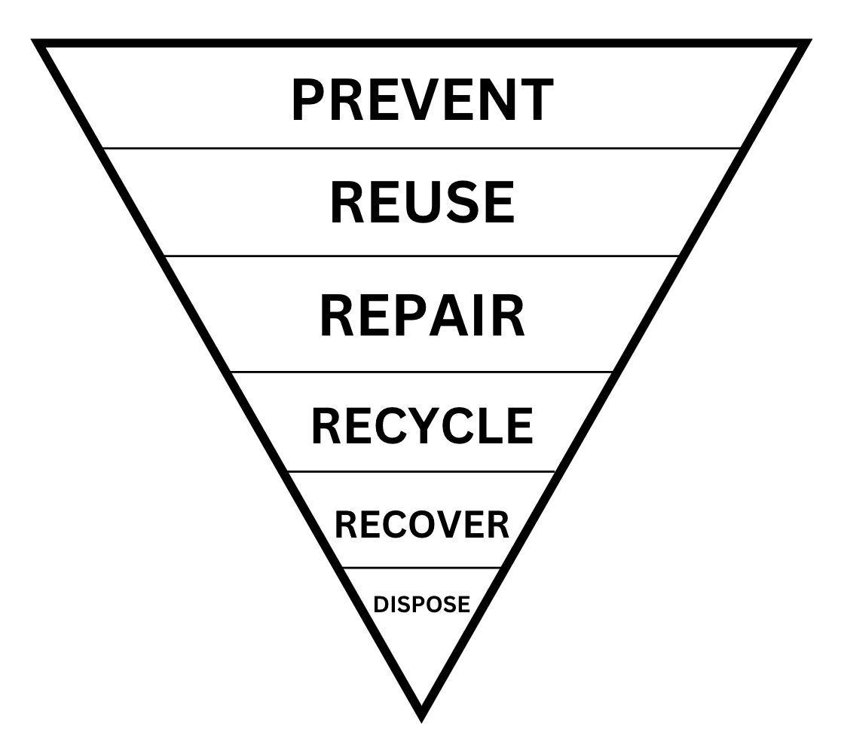
Waste Hierarchy

Sustainable Procurement
- All employees, volunteers and board members should ensure that all purchases and procurement decisions focus on sustainable products and services. Sustainable products and services can be described as being:
- Durable, easily upgraded and repairable
- Energy efficient and resource efficient
- Ethically sourced
- Fit for purpose and provide value for money
- Made with maximum use of post-consumer materials
- Made with minimum use of virgin materials
- Reusable, refillable and recyclable
- Made locally
- All employees, volunteers and board members should take into account ‘whole life costing’ when making purchasing and procurement decisions. Whole life costing involves taking into account the total cost of a product or service over its lifetime, including but not limited to:
- Purchase price
- Delivery costs
- Installation costs
- Running costs (e.g. energy use, water consumption, water-efficient treatment)
- Expected lifespan
- Maintenance costs
- Disposal costs
- All employees, volunteers and board members involved in the procurement of goods and services should consider sustainability in their purchasing decisions. All employees should:
- Where possible, buy refurbished or second-hand rather than new.
- Consider goods and services that may be manufactured, used and disposed of in an environmentally responsible way.
- Give preference, where items are of a similar cost, to those that are manufactured with a high recycled content.
- Specify items that can be reused, refilled, recycled or remanufactured.
- Favour suppliers that are committed to resource efficiency improvements.
- Favour suppliers who are local and where goods or services are produced locally.
- Consider 'whole-life' costs and impacts when assessing equipment for purchase as well as alternative models to outright purchase (e.g. leasing).
- Consider grouping orders and ordering in bulk to reduce the number of deliveries.
- Consider products and services with environmental labels. (E.g. Soil Association Organic, Fairtrade, Rainforest Alliance, European Energy Label, UK Fuel Economy Label, FSC Certified, etc.)
- Work proactively with companies and the community at large to progress resource efficiency initiatives and exchange good practice.
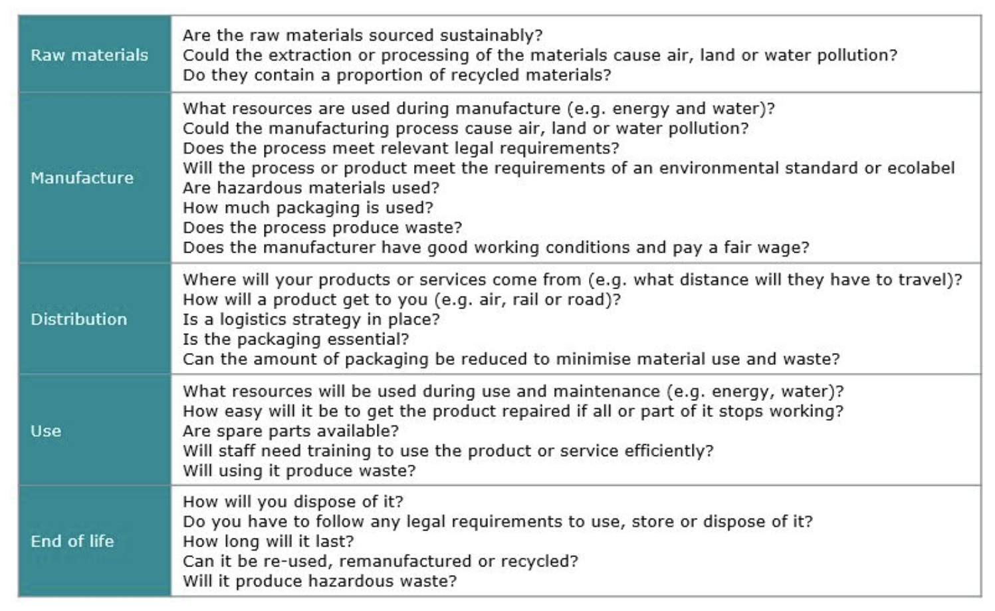
- All [employees, volunteers and board members] will consult the sustainable procurement checklist when purchasing goods and services.

Sustainable Procurement Checklist (Zero Waste Scotland)

Sustainable projects for Community Transition
The idea of implementing sustainable projects for community transition involves taking concrete actions that reflect the values of your museum while positively impacting the community's sustainability. These projects can vary in scale, ranging from small initiatives within your museum premises to larger community-wide efforts. The key is to ensure that these projects align with your institution's values and contribute to the overall sustainable evolution of the community.
To begin, it's crucial to utilise established assessment frameworks to evaluate your initiatives thoroughly. These frameworks can provide valuable insights into the current state of sustainability within your community and help identify areas where improvements can be made. By conducting comprehensive assessments, you can pinpoint focal areas for improvement and develop a clear understanding of the challenges and opportunities present.
Once you have identified these focal areas, the next step is to develop compelling arguments to support your project and campaign. This involves not only outlining the potential benefits of your initiatives but also addressing any concerns or objections that may arise. For example, if you're conducting an energy audit, you would identify optimal strategies for improving energy efficiency or transitioning to renewable energy sources. Additionally, estimating associated costs can help make a case for investment in sustainable practices.
Overall, sustainable projects for community transition require careful planning, assessment, and advocacy. By leveraging established frameworks, identifying focal areas for improvement, and developing compelling arguments, your institution can play a significant role in driving positive change towards sustainability within your community.

For Inspiration
Launched on International Museums Day, "Reimagining Museums for Climate Action" is a global competition that invites diverse groups, including designers, architects, artists, and indigenous communities, to envision and redesign museums to catalyse equitable and sustainable futures in the era of climate change.
The competition generated numerous innovative concepts, eight of which were selected for development into exhibits showcased at Glasgow Science Centre during COP26. These exhibits offer a spectrum of approaches addressing climate mitigation and adaptation, from enhancing mineralisation to fostering community-led adaptation efforts, all of which you can find in our Resources Document
Furthermore, the Museums for Climate Action website features 71 additional concepts, providing a wealth of information and inspiration for museums seeking to enhance their climate action efforts. Common themes include the potential for museums to stimulate community climate action, facilitate dialogue, incorporate indigenous knowledge, promote renewable energy, and foster the circular economy.
Overall, this shows the pivotal role museums can play in climate action by reimagining their spaces, practices, and programs to address the urgent challenges posed by climate change.

X. Glossary
Adaptation: COPE: ‘dealing with the consequences’. Any action to reduce vulnerability to the actual or expected impacts of climate change (Sniffer). Adaptive climate change measures and policies are implemented to enhance the resilience of societies and businesses against climate change impacts like floods and heatwaves.
Carbon Footprint: A carbon footprint quantifies the total amount of CO2 equivalent emissions released into the atmosphere due to the activities of a specific individual, organisation, or community within a specified time period.
Carbon Neutrality: (see also Net Zero). This refers to achieving a state of equilibrium between carbon emissions released into the atmosphere and those absorbed from it by carbon sinks or through carbon sequestration. This balance is attained when human-generated greenhouse gas emissions are offset by removals or absorptions of an equivalent amount. Organisations can attain carbon neutrality by compensating for their emissions. It's important to note that being labelled "carbon neutral" doesn't necessarily imply that a company has actively reduced or mitigated its carbon emissions.
Circular Economy: A system focused on eradicating waste by promoting the ongoing reuse and repurposing of resources. Remember: Reduce, reuse, recycle.
Climate Justice: A term used to frame global warming as an ethical and political issue, rather than one that is purely environmental. It acknowledges that those who contributed least to climate change, are also those who are now most affected by its impacts.
Greenhouse Gases: (GHGs) are the primary contributors to global warming and climate change. Major GHGs include carbon dioxide (CO2), methane (CH4), and nitrous oxide (N2O), while other potent but less prevalent gases include hydrofluorocarbons (HFCs), perfluorocarbons (PFCs), sulphur hexafluoride (SF6), and nitrogen trifluoride (NF3).
Just Transition: Making sure the transition to environmentally and socially sustainable jobs, sectors and economies, is done in a way which creates decent, fair and high value work, and does not negatively affect the current workforce and overall economy. (Sniffer)
Just Resilience: Addressing the social and economic inequalities created by the exposure to climate risk and the ability to deal with them without increasing the vulnerability of other groups. (Sniffer)
Mitigation: CUT: ‘preventing the causes of climate change’. Any action to reduce or prevent greenhouse gas emissions (Sniffer). Climate change policies and measures designed to mitigate greenhouse gas emissions from both companies and governments, with the goal of minimising the global effects of climate change, including reducing the volume and intensity of fossil fuel combustion.
Net Zero: Achieving a balance between greenhouse gas emissions and removal (sequestration). Scotland has a target to achieve net zero by 2045. (Sniffer)
Net Zero Emissions: Net zero emissions entail reducing greenhouse gas (GHG) emissions to align with the goal of limiting global warming to 1.5°C and offsetting any remaining emissions by enhancing carbon sinks. The primary objective is to minimise emissions as much as feasible (as per the Science-based target initiative, aiming for a 90-95% reduction to align with a 1.5°C pathway). The UK has implemented a legally binding target to achieve net zero emissions by 2050.

Offsetting: Carbon offsetting refers to the action or process of compensating for carbon dioxide emissions resulting from industrial or other human activities by engaging in schemes aimed at making equivalent reductions of carbon dioxide in the atmosphere. It involves reducing or removing emissions of carbon dioxide or other greenhouse gases (GHGs) to offset emissions generated elsewhere. Carbon offsets entail indirect sequestration achieved through the purchase of carbon credits. This practice may involve investing in initiatives such as tree plantations, renewable energy projects, energy efficiency programs, and more. It's important to note that carbon offsets are not considered a direct reduction in one's carbon footprint but are reported separately.
Resilience: The ability of a system and its component parts to anticipate, absorb, accommodate, or recover from the effects of a hazardous event in a timely and efficient manner, including through ensuring the preservation, restoration, or improvement of its essential basic structures and functions. (UN Office for Disaster Risk Reduction)
Sequestration: CAPTURE: ‘getting greenhouse gases out of the atmosphere’. (Sniffer)
SDGs: The United Nations Department of Economic and Social Affairs has set forth 17 social goals aimed at advancing prosperity while safeguarding the planet. These goals encompass a wide range of objectives, including eradicating poverty, ensuring access to quality education and healthcare, promoting gender equality, fostering sustainable communities, and combating climate change.

XI. Resources
- Be part of Museums and Galleries Scotland’s Scottish Museums Climate Network. To join you can email: climate@museumsgalleriesscotland.org.uk
- Apply to: Business Energy Scotland’s free Energy Efficiency Assessment
- Become members of: Member of Green Arts Initiative
- Business Energy Scotland Resource Hub
- Community Climate Adaptation Route Map
- Fife Contemporary 'Artists Environmental Resource’
- Creative Carbon Scotland's 'Guide to Environmental Policies’
- Information about electric vehicles and installing charging points

1. Training
- Green Champions Training (free)
- Climate Literacy Training, Keep Scotland Beautiful
- Becoming Climate Resilient Training, Sniffer

2. How the SDGs relate to museums, and vice versa
- Curating tomorrow: ‘Museums and the Sustainable Development Goals: a how-to guide for museums, galleries, cultural institutions and their partners’ (2019)
- Curating Tomorrow: ‘Mainstreaming the Sustainable Development Goals: a results framework for galleries, libraries, archives and museums’ (2021)
- ICCROM: ‘Our Collections Matter Toolkit’
- United Nations: ‘170 Actions to Combat Climate Change’
- The Good Life Goals: ‘A Goal Without a Plan is just a Wish’

3. Further Reading on the Impacts of Climate Change
- Climate Change 2007: Synthesis Report - Summary for Policymakers
- Climate Outreach’s guide: ‘Theory of change: creating a social mandate for climate action’ (2020)

SDGs
- Our World In Data
- The United Nations News, Climate and Environment

Climate Change and Indigenous People
- Our Word in Data: Sustainable Development Goals Tracker
- The United Nations: Progress with Sustainable Development Goal 13, Take Urgent Action to Combat Climate Change and its Impacts
- Climate change and Indigenous peoples - United Nations Permanent Forum for Indigenous Issues Considers Reports on Climate Change Policies
- Indigenous Peoples, Indigenous Voices: ‘Climate Change and Indigenous Peoples’ (2008)
- United Nations Department of Social and Economic Affairs, Indigenous Peoples: ‘Climate Change’
- UNFCCC, Local Communities and Indigenous Peoples Platform Web Portal

Climate change, women and girls
- IUCN Gender and Environment Resource Centre
- UNFCCC, ‘Introduction to Gender and Climate Change’
- UN Womenwatch: ‘Women, Gender Equality and Climate Change

Climate change and human migration and displacement
- International Organization for Migration (IOM): ‘Migration, Environment and Climate Change’
- Migration Data Portal

Climate change and nature
- International Union for the Conservation of Nature, Climate Change
- NASA Global Climate Change
- UNEP World Environment Situation Room

4. Greenhouse Gas Emissions
- The Scope 3 Evaluator tool is a free online tool from the Greenhouse Gas Protocol and Quantis that makes it easier for organisations to measure, report, and reduce emissions throughout their value chain.
- The Climate Toolkit provides guidance notes for museums on many aspects of reducing greenhouse gas emissions, with case studies on how US museums and botanic gardens are already reducing their carbon footprint.
- The UNFCCC Climate Neutral Now encourages organisations to make a commitment to reduce their greenhouse gas emissions, with a four-step approach: measure, reduce, report and contribute.
- The SME Climate Hub is based around a commitment to reduce greenhouse gas emissions by 50% by 2030 and Net Zero by 2050, and to report on a yearly basis. Museums can take part in the SME Climate Hub. It includes a repository of tools to help organisations to measure, reduce and offset their emissions.
- Julie’s Bicycle has developed a set of online tools, the ‘Creative Green Tools’, that cultural organisations can use to calculate their greenhouse gas emissions.
- Ki Culture have developed a set of ‘Ki Books’ dedicated to particular sustainability themes, including waste reduction and energy.

5. Reimagining Museums for Climate Action
- Weathering With Us (Singapore)
- Existances (Brazil)
- Elephant in the Room (USA)
- Museum of Open Windows (UK)
- Dundee Museum of Transport (UK)
- Story:Web (UK)
- A Series of Collective, Non-Statistical Evidence (Indonesia)
- Natural Future Museums (Brazil)

