TEMPLATE Environmental Action Plan
Insert / delete words in green as appropriate

We endeavour to:
- Comply with and exceed all relevant regulatory requirements.
- Continually improve and monitor performance to reduce environmental impacts and prevent pollution.
- Prioritise reducing our emissions over offsetting.
- Embed environmental sustainability into our development plans.
- Incorporate environmentally conscious thinking into all decision making.
- Increase employee, volunteers awareness and training.
- Make our suppliers, stakeholders, accreditors, public etc aware of our policies and to explain our reasons for implementing it.

Responsibility
who are responsible for ensuring that this environmental action plan is implemented, reviewed and updated. However, all employees, volunteers, freelancers and board members have a responsibility to ensure that the aims and objectives of this policy are met and complied with.

We already = tick or colour this box if complete
We will = include target date for achieving this action e.g. August 2024

Action Plan
Utilities and energy | We already | We will
Record and monitor our utility use (electricity, other fuels, water) based on our meter readings and bills.
Use a renewable energy provider to power office, exhibition, museum spaces.
Ensure that all new office equipment must have as high an energy rating as possible, and is only purchased new when a suitable second hand option is unavailable.
Ensure that all light bulbs needing replaced are replaced with more energy efficient bulbs (e.g. LED)
Install motion sensors for all lighting.
Install solar panels.
Have heating systems operated on a timer basis and ensure that all lights, heaters and electronic equipment are switched off when not in use. At the end of the working day, the employee leaving the place should check equipment to ensure that everything is switched off (e.g. light switches, water heater switches, etc) unless otherwise labelled (e.g. fridge, freezer).
Install water efficient appliances (e.g. dual-flush cisterns, sensor-controlled, push-button taps, aerated taps).
Encourage employees and volunteers to dress appropriately for the season and weather conditions rather than relying on turning up heaters.
Waste | We already | We will
Record and monitor all of our waste based on waste transfer notes supplied by our waste contractor(s) and bills.
Minimise waste by only ordering what we need and monitoring stock levels.
Follow national guidance to minimise waste.
Operate in line with the waste hierarchy (see Appendix) and prioritise waste prevention, followed by reuse.
Ensure that all employees, volunteers and freelancers use available recycling facilities and that bins are labelled clearly and appropriately.
Ensure that surplus food is either stored appropriately or preserved to make sure none is wasted.
Collect and recycle all unavoidable food waste (such as egg shells, skins or peelings, coffee grounds, etc.) through food waste collection service.
Compost unavoidable food waste.
Choose suppliers which offer refillable and reusable packaging options where possible.
Cafés - register with the Refill app and network so that customers and employees can refill their reusable water bottles and cups.
Encourage customers to use reusable cups and containers.
Ensure that [employees, volunteers and freelancers] use reusable cups and containers - both on premises and when working off-site. Where possible for events, activities and meetings, all staff are expected to use reusable items such as cups, bottles, containers, crockery and cutlery to avoid the use of single-use disposable items. Employees running outdoor sessions should encourage [public] to bring their own reusable items.
Provide washable hand towels or hand dryers instead of disposable paper towels in bathrooms, kitchens and public spaces.
Printing | We already | We will
Ensure that printing is kept to a minimum. Internal minutes and documents should be circulated electronically and printed only when necessary. Contracts, invoices and other correspondence should be sent electronically where possible.
Minimise paper and ink usage by printing double-sided, black and white and using multiple pages per sheet. Documents and correspondence should only be printed when strictly necessary.
Recycle all printer ink cartridges.
Ensure that all paper is:
- Made from 100% recycled paper
- FSC (Forest Stewardship Council) certified
Ensure that paper is only laminated (e.g. for display boards) where more durable forms of paper (e.g. waterproof paper) are not suitable.
Finance | We already | We will
Bank with an environmentally conscious bank.
Choose a pension provider which offers ethical investment options.
Use digitally-based accounting and are paperless where possible.
Budget for increased maintenance costs.
Ensure that enough insurance cover is in place to manage the risk of climate shocks and stresses.
Procurement | We already | We will
Consider leasing equipment or hiring services which are more ethical, responsible and cost-effective than an outright purchase.
Ensure that all purchases and procurement decisions focus on sustainable products and services. (see Appendix)
Ask all suppliers to provide their environmental policy.
Work with our suppliers and partners to encourage them to apply the same principles, using their environmental sustainability policy as a criterion for procurement or partnership where appropriate. This will impact our procurement approach and choice of partners amongst other areas.
Electronics | We already | We will
Buy refurbished or second hand electronic equipment rather than new where possible.
Data | We already | We will
Ask employees to regularly delete emails and tidy and remove items from our online storage systems (e.g. GDrive) in order to reduce our digital carbon footprint.
Cleaning | We already | We will
Use environmentally friendly cleaning products where possible to reduce pollution and negative environmental impact. These will also be bought in bulk and/or refillable and reusable where possible. - see Collections Care Policy.
Food | We already | We will
Offer only vegetarian and vegan food (cafés) and at catered events.
Use local produce, derived from sustainable farming practices where possible and/or organic where affordable.
Travel | We already | We will
Record and monitor our museums travel. All employees, volunteers, freelancers and board members are required to record and claim all travel expenses through our travel and expenses form. This enables us to calculate business emission reports.
Monitor visitor travel and record the forms of transport they use to visit us.
Encourage forms of active travel where possible (e.g. walk, scoot, cycle, etc.).
Encourage car sharing or using public transport where forms of active travel are not possible.
Ensure that our cars/vans only used for the transportation of large or heavy goods and collections, and where other forms of transport are not possible. Hire vehicles rather than privately owning them where possible.
Encourage consideration of video conferencing for meetings where possible and appropriate, rather than travelling.
Sign up to a car club scheme to encourage all employees, volunteers and board members to use these hybrid vehicles where active travel, car sharing or public transport options are not possible.
Provide secure cycle storage.
Install electric vehicle charging points.
Adaptation | We already | We will
Carry out contingency planning by developing a flood / weather emergency plan.
Carry out preventative conservation (environmental monitoring and control) - see Collections Care Policy.
For renovations or building work, areas will be (re)designed with the new climate in mind to cope with chronic change and recover from extremes. Retrofitting e.g. blinds, insulation, water efficiency measures, airs ource heat pumps, battery banks, solar panels, horizontal plasterboard, raised ring mains, wall mounted boilers.
Valuables and critical equipment are stored in the safest places e.g. away from areas that could flood.
Ensure that clothing and PPE provided is available and suitable for hot and cold conditions.
Incorporate nature-based solutions - plant trees, grass, plants, green roofs, water butts and greenery in outdoor space to provide shade, and help with rainfall absorption.
Avoid impermeable surfaces which encourage surface water in outdoor spaces (e.g. tarmac) and use permeable surfaces instead (e.g. grass, gravel).
Carry out regular and timely maintenance (e.g. gutters, roofs, slates, chimneys, roofline) to reduce vulnerability to winds.
Advocacy, communication and raising awareness: | We already | We will
Advocate good environmental practices and policies across all areas of our work.
Embed sustainability responsibility in role descriptions.
Promote environmental awareness among all employees, volunteers, freelancers and board members of museum name and encourage them to work in an environmentally responsible manner. This policy should be shared and emphasised during inductions.
Communicate our environmental commitment to customers, suppliers, stakeholders, participants and the public and encourage them to support it. E.g. incorporating messages about climate and environmental responsibility when planning exhibitions, displays, interpretation panels, events, activities and meetings.
Establish a Green Team.
Actively raise awareness and promote climate consciousness, repair, reuse and environmentally-responsible practices throughout our work and events. The collection will continue to be used to provide education and lifelong learning activities which relate to the environment and the local ecology.
Progress opportunities for environmental and climate justice related projects and event programming.
Highlight our environmental work and other examples of good practice on social media and via our website.
Sign up as free members with Highlands & Islands Climate Hub.
Sign up to be part of Museums and Galleries Scotland’s Scottish Museums Climate Network.
Sign up as free members of Creative Carbon Scotland’s Green Arts Initiative.
Offer climate literacy and environmental training to all employees, volunteers and board members on a rolling basis.
Ensure that the climate emergency is featured on the board's agenda..
Have information on our website about sustainable and active travel options for how to travel to the museum.
Monitoring and improvement | We already | We will
Comply with and exceed all relevant regulatory requirements.
Conduct an annual carbon audit to measure progress and act on any recommendations for improvement.
Review and update this policy at least annually in consultation with employees, volunteers, freelancers, board members and stakeholders for greater commitment and improved performance.
Assess any significant new or revised policies, practices and procedures for their impact on environmental sustainability.
Appendix
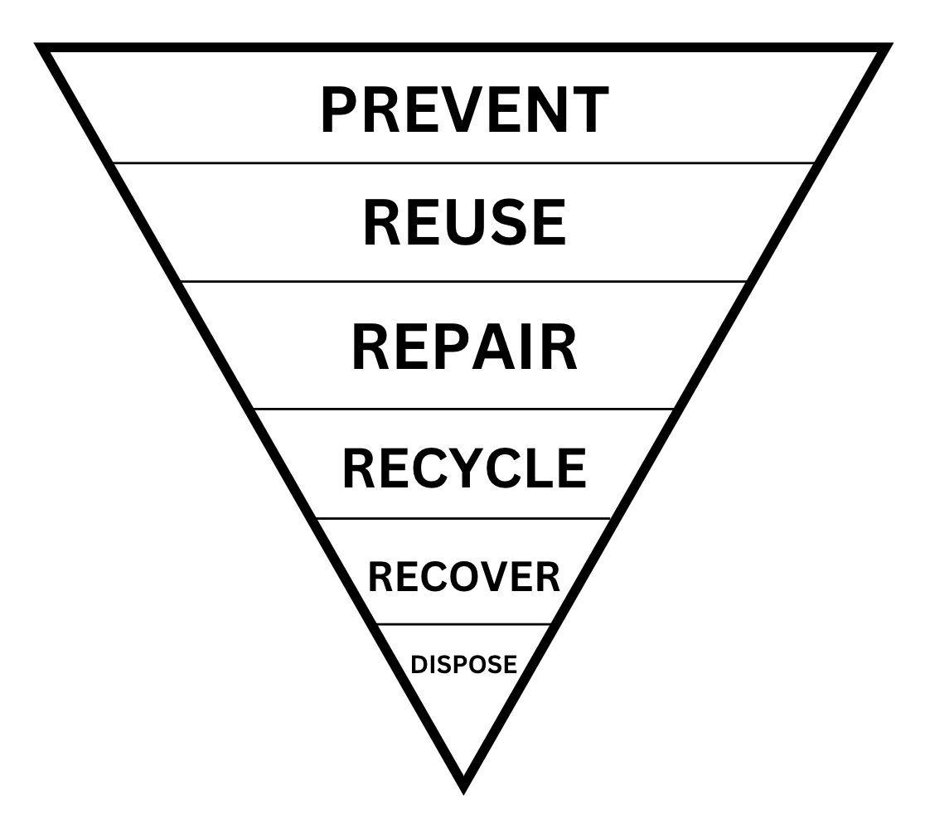
Waste Hierarchy

Sustainable Procurement
- All employees, volunteers and board members should ensure that all purchases and procurement decisions focus on sustainable products and services. Sustainable products and services can be described as being:
- Durable, easily upgraded and repairable
- Energy efficient and resource efficient
- Ethically sourced
- Fit for purpose and provide value for money
- Made with maximum use of post-consumer materials
- Made with minimum use of virgin materials
- Reusable, refillable and recyclable
- Made locally
- All employees, volunteers and board members should take into account ‘whole life costing’ when making purchasing and procurement decisions. Whole life costing involves taking into account the total cost of a product or service over its lifetime, including but not limited to:
- Purchase price
- Delivery costs
- Installation costs
- Running costs (e.g. energy use, water consumption, water-efficient treatment)
- Expected lifespan
- Maintenance costs
- Disposal costs
- All employees, volunteers and board members involved in the procurement of goods and services should consider sustainability in their purchasing decisions. All employees should:
- Where possible, buy refurbished or second-hand rather than new.
- Consider goods and services that may be manufactured, used and disposed of in an environmentally responsible way.
- Give preference, where items are of a similar cost, to those that are manufactured with a high recycled content.
- Specify items that can be reused, refilled, recycled or remanufactured.
- Favour suppliers that are committed to resource efficiency improvements.
- Favour suppliers who are local and where goods or services are produced locally.
- Consider 'whole-life' costs and impacts when assessing equipment for purchase as well as alternative models to outright purchase (e.g. leasing).
- Consider grouping orders and ordering in bulk to reduce the number of deliveries.
- Consider products and services with environmental labels. (E.g. Soil Association Organic, Fairtrade, Rainforest Alliance, European Energy Label, UK Fuel Economy Label, FSC Certified, etc.)
- Work proactively with companies and the community at large to progress resource efficiency initiatives and exchange good practice.
- All employees, volunteers and board members will consult the sustainable procurement checklist when purchasing goods and services.
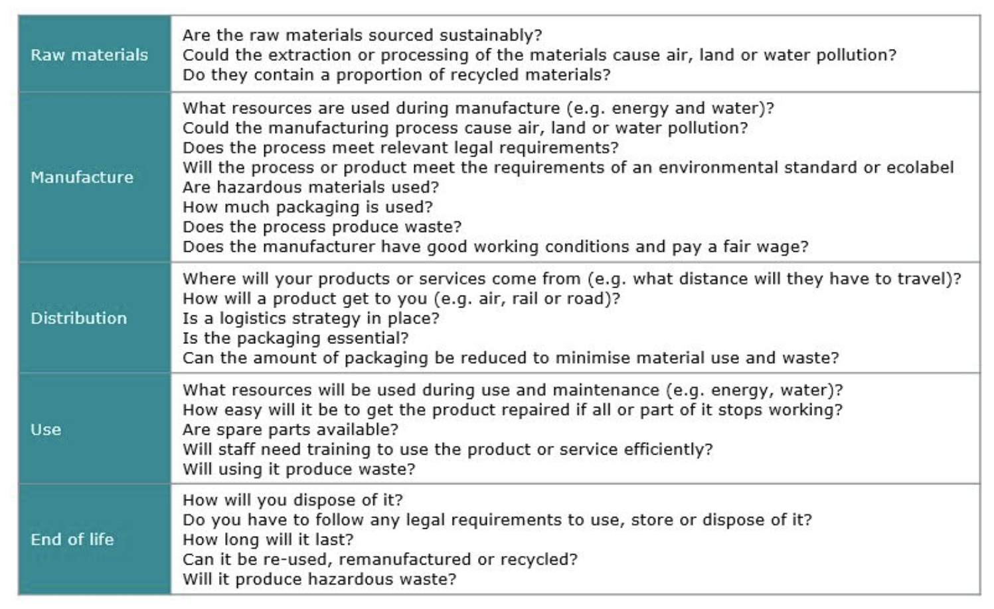

Sustainable Procurement Checklist (Zero Waste Scotland)

