Glossary

Adaptation: COPE: ‘dealing with the consequences’. Any action to reduce vulnerability to the actual or expected impacts of climate change (Sniffer). Adaptive climate change measures and policies are implemented to enhance the resilience of societies and businesses against climate change impacts like floods and heatwaves.

Carbon Footprint: A carbon footprint quantifies the total amount of CO2 equivalent emissions released into the atmosphere due to the activities of a specific individual, organisation, or community within a specified time period.

Carbon Neutrality: (see also Net Zero). This refers to achieving a state of equilibrium between carbon emissions released into the atmosphere and those absorbed from it by carbon sinks or through carbon sequestration. This balance is attained when human-generated greenhouse gas emissions are offset by removals or absorptions of an equivalent amount. Organisations can attain carbon neutrality by compensating for their emissions. It's important to note that being labelled "carbon neutral" doesn't necessarily imply that a company has actively reduced or mitigated its carbon emissions.

Circular Economy: A system focused on eradicating waste by promoting the ongoing reuse and repurposing of resources. Remember: Reduce, reuse, recycle.

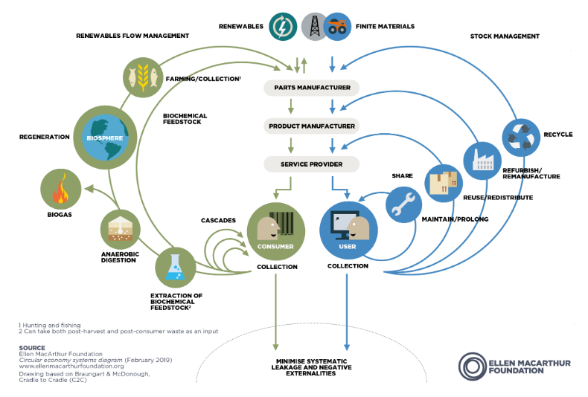

Climate Justice: A term used to frame global warming as an ethical and political issue, rather than one that is purely environmental. It acknowledges that those who contributed least to climate change, are also those who are now most affected by its impacts.

Greenhouse Gases: (GHGs) are the primary contributors to global warming and climate change. Major GHGs include carbon dioxide (CO2), methane (CH4), and nitrous oxide (N2O), while other potent but less prevalent gases include hydrofluorocarbons (HFCs), perfluorocarbons (PFCs), sulphur hexafluoride (SF6), and nitrogen trifluoride (NF3).

Just Transition: Making sure the transition to environmentally and socially sustainable jobs, sectors and economies, is done in a way which creates decent, fair and high value work, and does not negatively affect the current workforce and overall economy. (Sniffer)

Just Resilience: Addressing the social and economic inequalities created by the exposure to climate risk and the ability to deal with them without increasing the vulnerability of other groups. (Sniffer)

Mitigation: CUT: ‘preventing the causes of climate change’. Any action to reduce or prevent greenhouse gas emissions (Sniffer). Climate change policies and measures designed to mitigate greenhouse gas emissions from individuals, organisations and governments, with the goal of minimising the global effects of climate change, including reducing the volume and intensity of fossil fuel combustion.

Net Zero: Achieving a balance between greenhouse gas emissions and removal (sequestration). Scotland has a target to achieve net zero by 2045. (Sniffer)

Net Zero Emissions: Net zero emissions entail reducing greenhouse gas (GHG) emissions to align with the goal of limiting global warming to 1.5°C and offsetting any remaining emissions by enhancing carbon sinks. The primary objective is to minimise emissions as much as feasible (as per the Science-based target initiative, aiming for a 90-95% reduction to align with a 1.5°C pathway). The UK has implemented a legally binding target to achieve net zero emissions by 2050.

Offsetting: Carbon offsetting refers to the action or process of compensating for carbon dioxide emissions resulting from industrial or other human activities by engaging in schemes aimed at making equivalent reductions of carbon dioxide in the atmosphere. It involves reducing or removing emissions of carbon dioxide or other greenhouse gases (GHGs) to offset emissions generated elsewhere. Carbon offsets entail indirect sequestration achieved through the purchase of carbon credits. This practice may involve investing in initiatives such as tree plantations, renewable energy projects, energy efficiency programs, and more. It's important to note that carbon offsets are not considered a direct reduction in one's carbon footprint but are reported separately.

Resilience: The ability of a system and its component parts to anticipate, absorb, accommodate, or recover from the effects of a hazardous event in a timely and efficient manner, including through ensuring the preservation, restoration, or improvement of its essential basic structures and functions. (UN Office for Disaster Risk Reduction)

Sequestration: CAPTURE: ‘getting greenhouse gases out of the atmosphere’. (Sniffer)

SDGs: The United Nations Department of Economic and Social Affairs has set forth 17 social goals aimed at advancing prosperity while safeguarding the planet. These goals encompass a wide range of objectives, including eradicating poverty, ensuring access to quality education and healthcare, promoting gender equality, fostering sustainable communities, and combating climate change.

