Historylinks East Sutherland Longhouse Project.
The Scottish Highlands have long been associated with isolation, a place of mystery with a challenging climate and a sparse population.
In 1773 and at a time when the British Empire was riding high, the formidable Dr Samuel Johnston and James Boswell travelled by stagecoach and horseback to visit the Western Isles. With their colonial sensibilities they did not hesitate to label the people they met as they journeyed through the Highlands as noble savages, a people who, because they spoke in an unfamiliar tongue and lived in a way that Johnson and Boswell were unaccustomed to, were seen as lacking. Any sign of elegance or manners they put down to English intervention.
Conversely, by the end of the 18th Century and the start of 19th Century the Highlands was beginning to become highly romanticised, particularly by writers Robert Burns and Sir Walter Scott. This resulted in further ‘othering’ of the Highlands in the form of stereotypical tartanry brought about by tourism at the turn of the 19th Century.
However, recent research is starting to uncover a more realistic and grounded view of the Highlands. With the repopulation of the area it is important for the next generations to realise that prior to the Highland Clearances the land was not a desolate place but full of thriving communities with connections to Europe and the rest of the world.
Many visitors to Historylinks Museum are interested in the Clearances. Some come from places such as Canada, Australia and the USA, specifically in search of their ancestors. Others find out about the Clearances when they arrive and see our display on the subject. They are versed in the aftermath, but few know what life was really like for Highlanders before the plans for improvement were put in place by the Duchess of Sutherland.
Therefore, Historylinks decided to explore life in 18th Century Dornoch Parish so that the people of the time could be better represented to visitors to the Museum and the local community.
Our Curator began to research and put together the bones of a project involving UHI, Dornoch Academy and the local community. In August last year we were awarded £15,400 to run the project and a Project Manager and Sessional Worker where appointed.
With the help of a local archaeologist and a copy of the Roy Military Map 1747-1755 a settlement was chosen from among the many farming communities scattered throughout the area. William Roy created the map in the wake of the Battle of Culloden in 1746. The British Government wanted to know exactly where people were in case of another Jacobite uprising. The resulting map is one of the most important maps of the 18th Century showing the many communities and large population inhabiting the fertile straths of the Highlands.

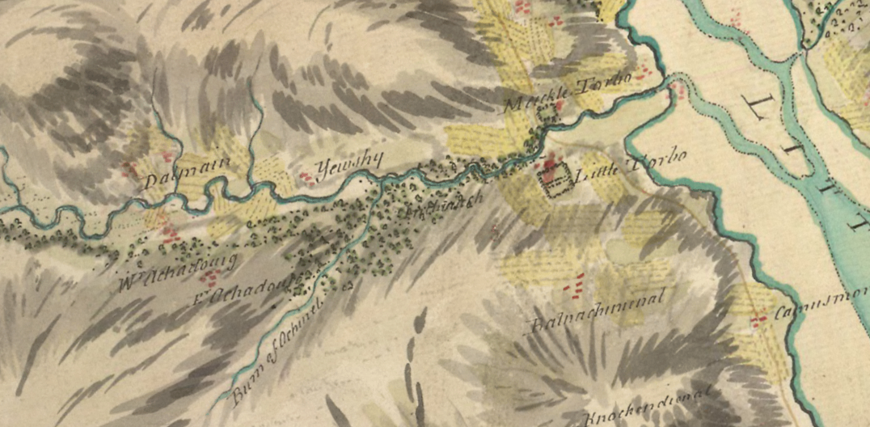
Roy Millitary map 1746-1747
This map led us to the settlement of Dalnamain in Strath Carnaig about 6 miles North West of Dornoch. It was chosen because of its proximity to the road and the lack of bracken and undergrowth. On exploration of the site we found the footings of longhouses, potato pits, corn drying kilns and a ridge and furrow system of farming still clear on the land. We found the site more and more fascinating as we realised that there was a Neolithic standing stone, hut circles and a relatively modern although derelict shepherd’s house on the site. It became clear that this site had been inhabited for thousands of years.
Paper research took us to the Sutherland Papers where we found that the site in 1812 was home to ten tenants and so presumably under the grass and heather there were the footings of ten houses.
Comparing the Roy map with subsequent Ordinance Survey maps revealed the land use over the years, with the cleared tenants houses used as material to build the enormous sheep enclosure that remains to this day.
On a visit to Timespan in Helmsdale our Project Manager discovered the names of the tenants who had lived at Dalnamain in pre-clearance times and from then on, the Project became about real people and their way of life.
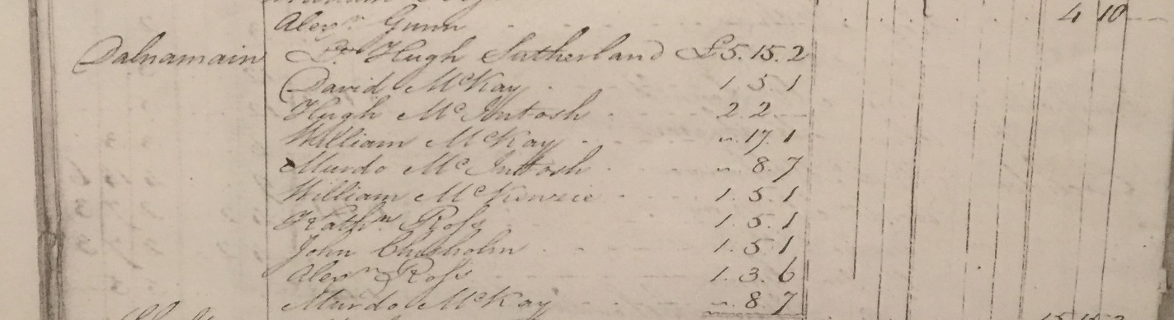
List of tenants in 1805 (Sutherland Estate Papers)

In Historylinks archive our Curator found the transcription of a diary written by John Matheson who was born in in Strath Carnaig and lived his young life at Brea, Dalnamain. Written in 1799 this diary gave us insight into the lives of the people in the Strath. They were not the insular, savage people that Johnston and Boswell would have us believe, but educated and outward looking. John served in the Sutherland Fencibles and was drawn to Glasgow to work in the textile industry. His carefully written account shows him to be an intelligent, sensitive man and the detail of his journaling helped us to understand the complexities of life in that half of the 18th Century.
Our Project Manager and Curator worked together to create workshops that would inform the local community about life in Dalnamain before the Clearances took place. They identified experts who could facilitate the workshops and the project began to come together. The programme, now in full swing, includes silversmithing, coppicing and willow weaving, cooking, construction and thatching, working with wool, leather craft, music and much more.

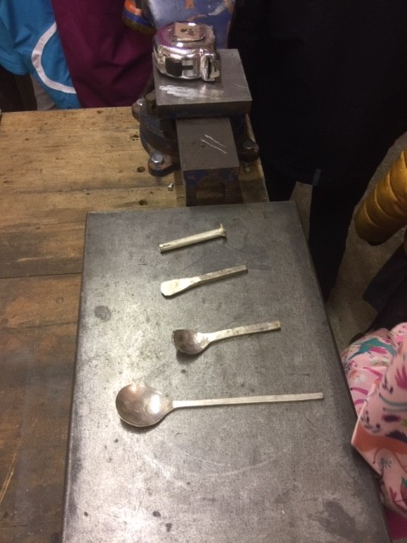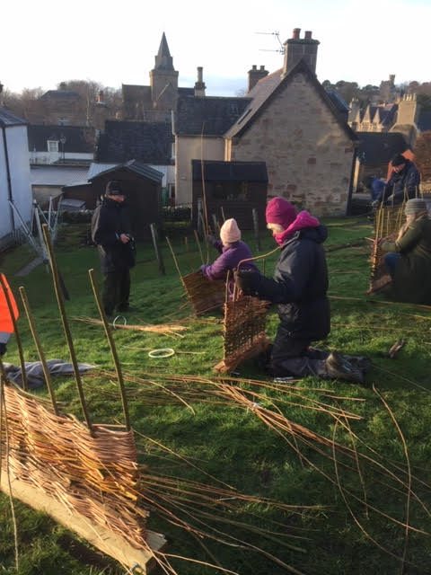
Silversmithing with Peter Rowland Willow Weaving with Pippa Tran
The workshops are diverse and engaging, they are designed to involve the whole community and immerse people in the culture of the time. Dr Elizabeth Ritchie from UHI will be helping community groups make sense of land use and events leading up to the clearances using maps and documents.
The site in Dalnamain has already seen students from Dornoch Academy and our own Young Curators Club carry out archaeological walk overs of the site and other groups will be plane tabling and surveying the area throughout the project.
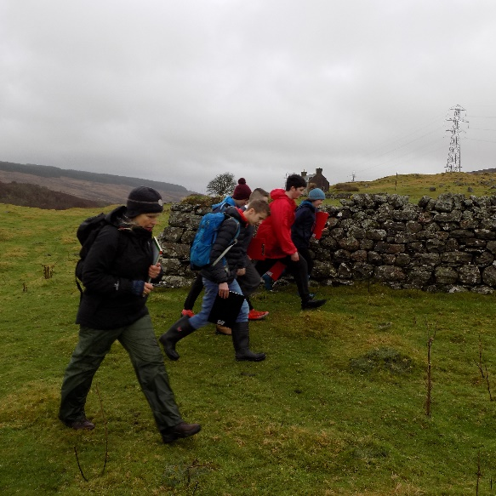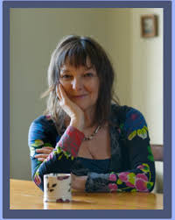
Archaeological walkover with Students from Storyteller Janis Mackay
Dornoch Academy

Award winning author, Janis Mackay, is going to be running creative writing workshops and telling us stories from the 18th century around a blazing fire in the Dornoch Castle Hotel. So, no matter how young or old, academic or practical, this project seeks to make the past accessible to everyone.
Amazingly, a random conversation between our Curator and a visitor from Jamaica brought to light a fascinating connection with Strath Carnaig and the West Indies. Through this meeting we were put in touch with Dr Michael Rhodes living in Devon. His wife is descended from the Sutherlands of Strath Carnaig and during the 18th Century some of the family were sent out to Jamaica to make their fortunes through sugar plantations. Further research revealed just how connected the Highlands was to the slave trade.
So, our project has only just begun but already we are building up a picture of a sophisticated community, self-sustainable but with links to the rest of Britain and the British Empire.
All our workshops are free and open to the public and there are still many to choose from. Just take a look at our poster and contact the museum to book a space.
The programme of events will culminate on Saturday 28th March when we host Changing Perceptions: Let’s Talk About Dalnamain. Kicking off with a site visit to Dalnamain led by Archaeologist, Anne Coombs, it will be a day to showcase the practical workshops that have taken place, together with talks by Dr Michael Rhodes and our Curator. A scale model of Dalnamain as it looked in the 18th Century, and created by Dave Mahoney and our Young Curators, will be on show at the heart of our Project exhibition in the Museum.
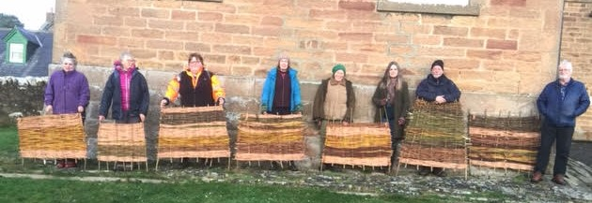
Willow weavers with their finished hurdles

